ARTIFICIAL INTELLIGENCE FOR

SOCIAL ENGINEERING DETECTION

NURSYUHADAH BINTI AHMAD SUDERMAN

UNIVERSITI TEKNIKAL MALAYSIA MELAKA

**BORANG PENGESAHAN STATUS LAPORAN**

JUDUL: [ARTIFICIAL INTELLIGENCE FOR SOCIAL ENGINEERING DETECTION]

SESI PENGAJIAN: [2024 / 2025]

Saya: ____[NURSYUHADAH BINTI AHMAD SUDERMAN]___________________

mengaku membenarkan tesis Projek Sarjana Muda ini disimpan di Perpustakaan Universiti Teknikal Malaysia Melaka dengan syarat-syarat kegunaan seperti berikut:

1. Tesis dan projekadalah hakmilik Universiti Teknikal Malaysia Melaka.
2. Perpustakaan Fakulti Teknologi Maklumat dan Komunikasi dibenarkan membuat salinan unituk tujuan pengajian sahaja.
3. Perpustakaan Fakulti Teknologi Maklumat dan Komunikasi dibenarkan membuat salinan tesis ini sebagai bahan pertukaran antara institusi pengajian tinggi.
4. * Sila tandakan (✓)

|  |  |  |
| --- | --- | --- |
| __________ | SULIT | (Mengandungi maklumat yang berdarjah keselamatan atau kepentingan Malaysia seperti yang termaktub di dalam AKTA RAHSIA RASMI 1972) |
| __________ | TERHAD | (Mengandungi maklumat TERHAD yang telah ditentukan oleh organisasi / badan di mana penyelidikan dijalankan) |
| ____✓____ | TIDAK TERHAD |  |

|  |  |  |
| --- | --- | --- |
|  |  |  |
| (TANDATANGAN PELAJAR) |  | (TANDATANGAN PENYELIA) |
| Alamat tetap: E-7-9 P/A DESA REJANG PERSIARAN REJANG, TAMAN SETAPAK JAYA 53300, WILAYAH PERSEKUTUAN KUALA LUMPUR |  | DR ZAHEERA BINTI ZAINAL ABIDIN |
|  |  | Nama Penyelia |
| Tarikh: __________________________ |  | Tarikh: __________________________ |

CATATAN: * Jika tesis ini SULIT atau TERHAD, sila lampirkan surat daripada pihak berkuasa.



ARTIFICIAL INTELLIGENCE FOR SOCIAL ENGINEERING DETECTION

NURSYUHADAH BINTI AHMAD SUDERMAN

This report is submitted in partial fulfillment of the requirements for the

Bachelor of [Computer Science (Computer Security)] with Honours.

FACULTY OF INFORMATION AND COMMUNICATION TECHNOLOGY UNIVERSITI TEKNIKAL MALAYSIA MELAKA

2025

# DECLARATION

I hereby declare that this project report entitled

[ARTIFICIAL INTELLIGENCE FOR SOCIAL ENGINEERING DETECTION

is written by me and is my own effort and that no part has been plagiarized

without citations.

STUDENT : NURSYUHADAH BINTI AHMAD SUDERMAN Date : ________

I hereby declare that I have read this project report and found

this project report is sufficient in term of the scope and quality for the award of

Bachelor of [Computer Science (Computer Security)] with Honours.

SUPERVISOR : DR ZAHEERA BINTI ZAINAL ABIDIN Date : ________

# DEDICATION

This work is dedicated to Allah Almighty, my creator, pillar, and source of wisdom, knowledge, and insight. Throughout this journey, He has been my source of strength, and I have only been able to fly on His wings.

To my beloved parents, Ahmad Suderman Bin Mohd Yaacob and Norayzuazlin Binti Mohd Ayob whom I wholeheartedly dedicate this study to. Thank you for being my source of inspiration and for your unwavering support and trust. To my brothers, whom I hold very dear to my heart.

To my supervisor, Dr Zaheera binti Zainal Abidin, for supporting and believing in me to accomplish this project. Finally, I want to thank my friends for being there for me during my bachelor's degree, sharing words of advice and support to help me accomplish this study.

# ACKNOWLEDGEMENTS

First and foremost, First and foremost, I would like to praise and thank Allah the Almighty, the Most Gracious, and the Most Merciful for His blessing given to me in completing this project. Peace and salutations to the Prophet Muhammad S.A.W, who has led all humanity from darkness to light.

I would like to express my heartfelt appreciation to Dr. Zaheera binti Zainal Abidin for her assistance in completing this assignment successfully. Her insightful thoughts have provided various inspirations and enlightenment for this project.

I'd also want to thank my dear parents and sisters for their encouragement and support during this effort. Their help and concern had given me confidence while I worked on this project. Finally, I am grateful to my friends who are ready to share their wisdom and have directly or indirectly guided me during this project.

# ABSTRACT

# ABSTRAK

# 

# table of contents

|  |  |
| --- | --- |
|  | **PAGE** |

DECLARATION ii

DEDICATION iii

ACKNOWLEDGEMENTS iv

ABSTRACT v

ABSTRAK vi

table of contents vii

list of tables xi

list of figures xii

List of Abbreviations xiv

List of ATTACHMENTS xv

Chapter 1: INTRODUCTION 1

1.1 Introduction 1

1.2 Problem Statement 2

1.3 Project Question 3

1.4 Objective 4

1.5 Project Scope 5

1.6 Project Contribution 5

1.7 Thesis Organization 5

1.8 Conclusion 7

Chapter 2: literature review 8

2.1 Introduction 8

2.2 Artificial Intelligence Based Detection 9

2.2.1 Social Engineering Attacks 9

2.2.1.1 Phishing 9

2.2.1.2 Supervised Learning 10

2.2.1.2.1 SVM 10

2.2.1.2.2 CoAP Request/Response 12

2.2.2 MQTT 13

2.2.2.1 Architecture 13

2.2.2.2 Quality of Service (QoS) 14

2.2.3 AMQP 15

2.2.3.1 Architecture 16

2.3 Critical Literature Review 17

2.3.1 Research paper I 17

2.3.2 Research paper II 18

2.3.3 Research paper III 20

2.3.4 Research paper IV 20

2.4 Summary of Research Papers Reviewed 22

2.5 Proposed Solution/ Further Project 25

2.6 Conclusion 26

Chapter 3: PROJECT METHODOLOGY 27

3.1 Introduction 27

3.2 Methodology 27

3.2.1 Requirement Analysis 28

3.2.1.1 Hardware Requirement 28

3.2.1.2 Software Requirement 29

3.2.2 System Design 29

3.2.3 Implementation 30

3.2.4 Testing 30

3.2.5 Deployment 30

3.2.6 Maintenance 32

3.3 Project Schedule and Milestones 33

3.3.1 Project Milestones 33

3.3.2 Project Gantt Chart 34

3.4 Conclusion 35

Chapter 4: ANALYSIS AND DESIGN 36

4.1 Introduction 36

4.2 Network System Architecture 36

4.2.1 Client 37

4.2.2 Server 37

4.2.3 Switch 37

4.3 Logical & Physical Design 38

4.3.1 Logical Design 38

4.3.2 Physical Design 39

4.4 Possible Scenario 39

4.5 Conclusion 42

Chapter 5: IMPLEMENTATION 43

5.1 Introduction 43

5.2 Software Development Environment Setup 43

5.3 Software Configuration Management 44

5.3.1 Scenario 1: CoAP 44

5.3.2 Scenario 2: AMQP 46

5.3.3 Scenario 3: MQTT 49

5.4 Collected Data (Bandwidth Usage, Latency and Throughput) 53

5.5 Implementation Status 57

5.6 Conclusion 58

Chapter 6: discussion 59

6.1 Introduction 59

6.2 Result and Analysis 59

6.3 Conclusion 63

Chapter 7: PROJECT CONCLUSION 64

7.1 Introduction 64

7.2 Project Summarization 64

7.3 Project Contribution 65

7.4 Project Limitation 65

7.5 Future Works 66

7.6 Conclusion 66

references 67

# list of tables

|  |  |
| --- | --- |
|  | **PAGE** |

Table 1.2‑1 Problem Statement 2

Table 1.3‑1 Project Question 3

Table 1.4‑1 Project Objective 4

Table 1.6‑1 Project Contribution 5

Table 2.4‑1: Summary of Research Papers Reviewed 22

Table 3.2‑1: Hardware Requirement 28

Table 3.2‑2: Software Requirement 29

Table 3.2‑3: Example of Comparison Table generated after analysis of data is finished 31

Table 4.4‑1: Possible Scenarios 40

Table 5.4‑1 below shows the value of bandwidth usage, latency and throughput respective to the three protocols studied. 56

Table 5.4‑1: Comparison Table from Collected Data 56

Table 5.5‑1: Implementation Status 57

# list of figures

|  |  |
| --- | --- |
|  | **PAGE** |

Figure 1: Literature Review Structure Diagram 8

Figure 2: CoAP architecture (rfwireless-world.com) 9

Figure 3: CoAP Protocol Layers (payatu.com) 10

Figure 4: Confirmable Message (payatu.com) 11

Figure 5: Non-confirmable message (payatu.com) 11

Figure 6: Publish/Subscribe model in MQTT (Martí et al., 2019) 13

Figure 7: QoS0 (Sueda et al., 2019) 14

Figure 8: QoS1 (Sueda et al., 2019) 15

Figure 9: QoS2 (Sueda et al., 2019) 15

Figure 10: AMQP Architecture (Anusha, et al., 2017) 16

Figure 11: Sensors used to collect temperature, humidity and light (Corak et al., 2018) 18

Figure 12: Diagram of testbed’s processing unit (Corak et al., 2018) 18

Figure 13: Topology for (a) Experiment I and (b) Experiment II (Moraes et al., 2019) 19

Figure 14: Diagram of hardware used for the testbed (Pohl et al., 2018) 20

Figure 15: Experimental setup (Mijovic et al., 2016) 21

Figure 16 Waterfall Model 28

Figure 17: Data Processing and Obtaining Result 30

Figure 18: Example of Graph that compares three protocols based on Bandwidth Utilisation 31

Figure 19: Network System Architecture 36

Figure 20: Logical Design 38

Figure 21: Physical Design 39

Figure 22: Scenario 1: CoAP 40

Figure 23: Scenario 2: AMQP 40

Figure 24: Scenario 3: MQTT 41

Figure 25: CoAP server running at Server 44

Figure 26: CoAP client running at PC1 44

Figure 27: CoAP Client sending GET message 45

Figure 28: Server received CoAP messages from PC1 45

Figure 29: Wireshark Packet Capture (CoAP) 46

Figure 30: RabbitMQ installed in Server browser 46

Figure 31: Python code for sending message 47

Figure 32: Python code for receiving message 48

Figure 33: RabbitMQ Management Interface 48

Figure 34: Wireshark Packet Capture (AMQP) 49

Figure 35: Moisquitto loaded and running 50

Figure 36: Connection details 50

Figure 37: PC1 MQTTlens interface 51

Figure 38: PC2 MQTTlens interface 51

Figure 39: PC2 received 100 messages from PC1 52

Figure 40: Wireshark Packet Capture (MQTT) 52

Figure 41: Protocol Hierarchy for CoAP 53

Figure 42: Protocol Hierarchy for AMQP 53

Figure 43: Protocol Hierarchy for MQTT 54

Figure 44: Packet Length for CoAP 54

Figure 45: Packet Length for AMQP 55

Figure 46: Packet Length for MQTT 55

Figure 47: Conversations Statistics for CoAP 56

Figure 48: Conversations Statistics for AMQP 56

Figure 49: Conversations Statistics for MQTT 56

Figure 50: Bandwidth Usage Graph 60

Figure 51: Latency Graph 61

Figure 52: Throughput Graph 61

Figure 53: Average Packet Size, B (CoAP) from Wireshark 62

Figure 54: Average Packet Size, B (MQTT) from Wireshark 62

# List of Abbreviations

|  |  |  |
| --- | --- | --- |
| **IoT** | **-** | **Internet of Things** |
| **CoAP** | **-** | **Constrained Application Protocol** |
| **AMQP** | **-** | **Advanced Message Queuing Protocol** |
| **MQTT** | **-** | **Message Queue Telemetry Transport** |
| **TCP** | **-** | **Transmission Control Protocol** |
| **UDP** | **-** | **User Datagram Protocol** |

# List of ATTACHMENTS

|  |  |  |  |
| --- | --- | --- | --- |
|  | | | **PAGE** |
|  | | |  |
|  |  |  |  |
|  |  |  |  |
|  |  |  |  |
|  |  |  |  |
|  |  |  |  |

# INTRODUCTION

## Introduction

The Internet may now be used to link the great majority of the objects we use in our everyday lives. The Internet of Things (IoT) is a new technology that aims to build an ecosystem made up of intelligent gadgets and systems that can connect with one another via computer networks. The IoT protocols serves as a connection between the IoT device and the network it communicates with. Data sharing between devices is only possible due to IoT protocols and standards as these protocols represents a common language to all connected systems, independent of their brand, operating system or software tools used. Numerous communication protocols have been developed and implemented by different organizations to meet the demands of their IoT systems.

Even though several communication protocols have been created and implemented based on IoT systems, no standardized protocol for IoT exists. The correct protocol selection is one of the factors that determines the success of an IoT application (Elhadi, Marzak, Sael & Merzouk, 2018). This study aims to compare and evaluate three IoT communication protocols, namely CoAP, MQTT & AMQP in hope to determine their best-fit scenarios for future use. The protocols are analysed in an experimental IoT context based on the following metrics: bandwidth utilisation, latency, and throughput.

## Problem Statement

The problem that has been identified is summarized in Table 1-1 below:

Table 1.2‑1 Problem Statement

|  |  |
| --- | --- |
| **PS** | **Problem Statement** |
| **PS1** | No single protocol can handle all possible IoT use cases because each protocol has its own pros and cons. |

**PS1: No single protocol can handle all possible IoT use cases because each protocol has its own pros and cons.**

Engineers and developers must determine which protocol is appropriate for their intended IoT systems based on their because there is no one-size-fits-all communication protocol that is ideal for every deployment (Naik, N., 2017). Thus, it is vital for IoT engineers and developers to understand the characteristics, advantages, and disadvantages of protocols in order to integrate them in accordance with their intended system.

## Project Question

Three Project Question (PQ) is constructed based on the problem statement that need to be answered in this project. The summary of project question is shown in Table 1-2.

Table 1.3‑1 Project Question

|  |  |  |
| --- | --- | --- |
| **PS** | **PQ** | **Project Question** |
| PS1 | PQ2 | What are the differences in performance between CoAP, MQTT, and AMQP in terms of bandwidth usage, latency, and throughput? |
| PQ3 | Which is the best IoT protocol between CoAP, MQTT & AMQP based on the performance evaluation? |

**PQ1: What are the differences in performance between CoAP, MQTT, and AMQP in terms of bandwidth usage, latency, and throughput?**

Experimental analysis to find out the differences of performance between the protocols mentioned based on the metrics stated.

**PQ2: Which is the best IoT protocol between CoAP, MQTT & AMQP based on the performance evaluation?**

To find out the best IoT protocol based on the analysis done.

## Objective

Based on the project questions formulated in previous section, appropriate project objectives (PO) are developed. The Project Objective (PO) is summarized in Table 1-3.

Table 1.4‑1 Project Objective

|  |  |  |  |
| --- | --- | --- | --- |
| **PS** | **PQ** | **PO** | **Project Objective** |
| PS1 | PQ2 | PO2 | To assess capabilities of IoT communication protocols and compares their performance in terms of its bandwidth usage, latency, and throughput. |
| PQ3 | PO3 | To make recommendations on the protocols based on its the performance evaluation. |

**PO1: To assess capabilities of IoT communication protocols and compares their performance in terms of its** **bandwidth usage, latency, and throughput.**

Conduct an experimental analysis in GNS3 to evaluate performance of CoAP, MQTT & AMQP in terms of bandwidth usage, latency, and throughput.

**PO2: To make recommendations on the protocols based on its the performance evaluation.**

Produce a thorough performance comparison of three specific protocols: CoAP, MQTT & AMQP. The performance is evaluated in terms of bandwidth usage, latency, and throughput. Also selecting the which protocol is best for different cases based on the performance evaluation.

## Project Scope

The project's scopes are focused on the following aspects:

1. IoT protocols focused on are CoAP, MQTT & AMQP.
2. Metrics considered for performance analysis are bandwidth usage, latency, and throughput.
3. Platform used for the experimental analysis is GNS3.

## Project Contribution

The contribution of this project is summarized in Table 1-4.

Table 1.6‑1 Project Contribution

|  |  |  |  |  |
| --- | --- | --- | --- | --- |
| **PS** | **PQ** | **PO** | **PC** | **Project Contribution** |
| PS1 | PQ1 | PO1 | PC1 | Propose an experimental method to evaluate the performance of IoT protocols |
|  | PQ2 | PO2 | PC2 | A performance analysis of three specific protocols: CoAP, MQTT & AMQP in terms of bandwidth usage, latency, and throughput. |

## Thesis Organization

This report is divided into six chapters, namely Chapter 1: Introduction, Chapter 2: Literature Review, Chapter 3: Methodology, Chapter 4: Design, Chapter 5: Implementation, Chapter 6: Discussion and Chapter 7: Project Conclusion.

**Chapter 1: Introduction**

This chapter discussed the project's introduction, background, research problem, research question, objectives, scope, significance of the project, and report organization.

**Chapter 2: Literature Review**

This chapter discussed the related work from previous researchers and journals that are relevant to the project. It also provides a critical analysis of the current situation as well as recommendations based on relevant research. This chapter may provide us with the conceptual framework for doing the analysis, and the information obtained in this chapter may be used to the next chapter.

**Chapter 3: Methodology**

The chapter discussed the approach used to assess IoT performance based on bandwidth usage, latency, and throughput. This chapter also go through the details of the experiment.

**Chapter 4: Analysis and Design**

This chapter discussed on the analysis of the problems and requirements. This chapter also covers the design aspect of the experiment.

**Chapter 5: Implementation**

This chapter cover the activity involved in the implementation phase, the software used to conduct the analysis, the configuration used and the implementation status.

**Chapter 6: Discussion**

This chapter discussed on the analysis of results based on the data collected in previous chapter.

**Chapter 7: Project Conclusion**

This chapter summarizes the project and discusses whether or not the objectives were met, the project's strengths and weaknesses, and the contributions made.

## Conclusion

The problem description, aim, scope of the project, relevance, and projected output of the project are all clearly outlined in this chapter. The description of the related works to this project is detailed later in Chapter 2.

# literature review

## Introduction

Social engineering attacks have emerged as a significant cybersecurity threat, leveraging psychological manipulation to deceive individuals into divulging confidential information. Traditional security mechanisms, such as firewalls and antivirus software, often fail to detect these attacks due to their reliance on human error rather than system vulnerabilities. Artificial Intelligence (AI) has shown promising capabilities in detecting and mitigating social engineering attacks by analyzing patterns, behaviours, and linguistic cues. This chapter explores existing literature on social engineering attacks, AI-based detection techniques, classification techniques, existing AI GUI tools, machine learning software, and the challenges in implementing effective solutions.



Figure 1: Literature Review Structure Diagram

## Artificial Intelligence Social Engineering Detection Techniques

Artificial Intelligence (AI) has been employed to tackle various types of social engineering attacks, each of which exploits human psychology to deceive individuals or systems. The following subsections describe how AI technologies are applied to detect specific attack types, focusing on the detection methods, models used, and their respective strengths.

### Phishing

Phishing AI detects phishing through Natural Language Processing (NLP), behavioral analytics, and content inspection. Machine learning models such as Support Vector Machines (SVM), Random Forest, and deep learning architectures like LSTM and BERT are used to analyze message content, URLs, sender authenticity, and context to flag phishing attempts.

#### Support Vector Machines (SVM)

Support Vector Machine (SVM) model as a hyper plane in which several classes are represented. So that we may reduce the amount of mistake we make, SVM will create the hyper plane in an iterative fashion. SVM's purpose is to classify datasets such that a maximum marginal hyper plane may be discovered.

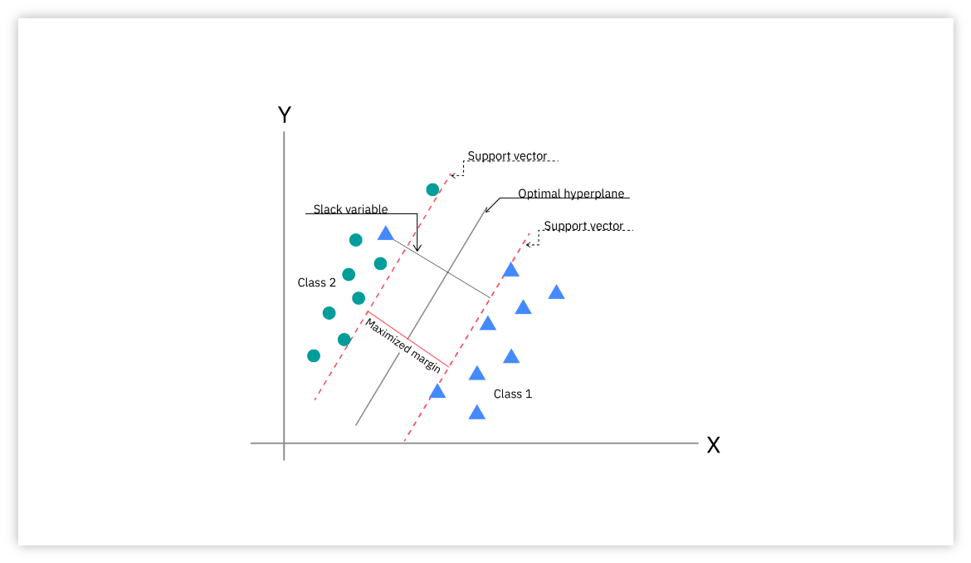

Figure 2:

Based on diagram above, clients either connect directly to the server or through a proxy that is linked to servers through HTTP for message transmission (Anusha, et al, 2017).

#### Structure Model

CoAP has two layers – application layer and a message layer (Figure 2.2-2). The Message layer is the lowest layer, and it was created to work with UDP and asynchronous switching. The request/response layer handles request/response messages and is concerned with communication methods.

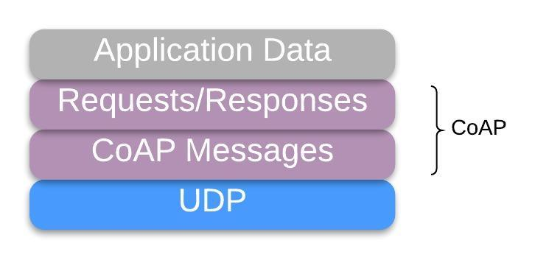

Figure 3: CoAP Protocol Layers (payatu.com)

#### CoAP Messages

CoAP includes certain measures at the application layer to achieve reliability because UDP is an unstable transport protocol owing to lack of an integrated retransmission mechanism (Mart et al., 2019). CoAP messages are divided into four types:

1. Confirmable (CON): The application layer implements a retransmission mechanism in the confirmable message, which ensures reliability (Tandale et al., 2017). This ensures that the transmission is secure. It requires the receiver to send an Acknowledgement (ACK) message to the sender to affirm whether or not they have received the message.
2. Non-confirmable (NON): Send-and-forget type of message (Tandale et al., 2017). It does not require an ACK message which means it does not need confirmation about its delivery. Instead, the server reply with a reset message (RST) (Moraes et al., 2019).
3. Acknowledgement (ACK): This message is sent in response to CON messages, confirming that they have been received.
4. Reset (RST): Sent as a response of a message that could not be processed (Martí et al., 2019). It represents a negative acknowledgement (Jan, Syed Roohullah, et al., 2016).

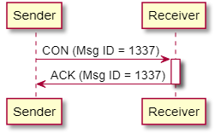

Figure 4: Confirmable Message (payatu.com)

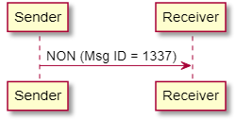

Figure 5: Non-confirmable message (payatu.com)

#### CoAP Request/Response

Requests are submitted using a Confirmable (CON) or Non-Confirmable (NON) message in this layer. Acceptance of these requests is dependent on the availability of the server. Messages might include a request, an answer, or nothing at all. GET, PUT, POST, and DELETE are the four request methods defined by the CoAP standard.

There are two types of response provided by CoAP:

1. Piggybacked is when client sends requests using CON or NON type message. Client then receive ACK confirmable message immediately, that is identified by token as response (Chen, Xi., 2014).
2. Separate response occurs when the server gets a CON type message but is unable to respond quickly by sending an empty ACK. When the response is ready, the server sends a new Confirmable message to the client with the response, and the client replies with a confirmable message with acknowledgment (Chen, Xi., 2014).

### MQTT

Message queue telemetry transport (MQTT) is a TCP-based publish-subscribe model developed by IBM and then open-sourced for messaging applications (Chen & Kunz, 2016) and is standardized at OASIS. MQTT aims at connecting embedded devices and networks with applications and middleware (Sueda et al., 2019).

#### Architecture

A publisher, a subscriber, and a broker manage and control the exchanged packets between publishers and subscribers in this message pattern. (Martí et al., 2019).

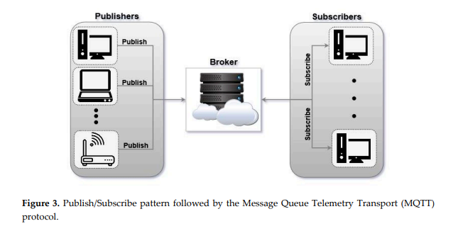

Figure 6: Publish/Subscribe model in MQTT (Martí et al., 2019)

Multiple clients acting as publisher and subscriber connect to a central broker in this publish-subscribe structure. Every subscriber is assigned to a broker-registered subject. Each publisher publishes to a certain subject, and the broker distributes the message to all subscribers (Tandale et al., 2017).

A subscriber can request and receive messages from a publisher. A publisher works with a broker to provide communications to subscribers about a given topic. Finally, the broker gets messages from publishers and sends them to interested subscribers.

#### Quality of Service (QoS)

Three types of QoS are used by MQTT:

1. QoS-0: The publisher sends the data to the broker and does not wait for Acknowledgement (ACK) from the broker. There is no retransmission, so, if the data send it not received then it means it gets lost. Silva et al. (2021) called this QoS as fire-and-forget.
2. QoS-1: The message is sent, and it is guaranteed to be delivered. To overcome the prior data issue, the publisher waits for a PUBACK (acknowledgement of receipt) from the broker. It retransmits the data if it does not get the ACK after a predetermined length of time.
3. QoS-2: When just one message is guaranteed to be sent to subscribers, no duplicates are possible. This level might be utilised in invoicing systems if duplicate or missing communications are unacceptable (Mart et al., 2019). The publisher submits data to the broker and waits for the broker to respond with a PUBREC (PUBlish RECeived) response. It discards the reference to the published material and sends a PUBREL (PUBlish RELeased) to the broker when it gets the PUBREC.

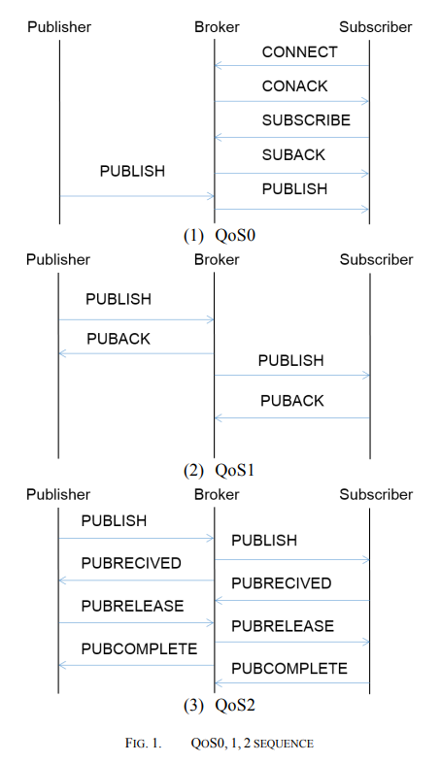

Figure 7: QoS0 (Sueda et al., 2019)



Figure 8: QoS1 (Sueda et al., 2019)



Figure 9: QoS2 (Sueda et al., 2019)

### AMQP

Advanced Message Queuing Protocol supports publish-subscribe and client-server communication and it has similar QoS mechanisms as MQTT. In 2003, John O'Hara of JPMorgan Chase in London, UK, created AMQP (Naik, 2017). AMQP maintains a broker to provide better reliability through queues, and it uses a TCP connection to save overhead at the client (Anusha, M., et al., 2017). This protocol is frequently used by organisations like NASA, who used it for the Nebula Cloud Computing Platform (Silva et al., 2021).

#### Architecture

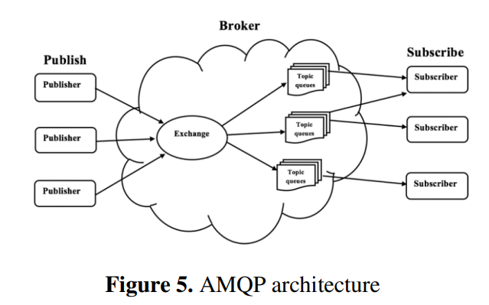

Figure 10: AMQP Architecture (Anusha, et al., 2017)

The Figure 2.2.3-1 depicts the AMQP architecture, which consists of three components: a broker, a sender, and a receiver. With the aid of a broker, communication between the publisher and the subscriber is exchanged. Unlike a MQTT broker, when Publisher publishes messages to Broker, messages are not routed immediately to the Subscriber. Instead, they are transferred to an Exchange. This Exchange is in charge of routing messages to queues based on routing keys, binding keys, or the Exchange type that has been configured. The message is held in the queue until the subscriber removes it (Uy & Nam, 2019).

## Critical Literature Review

Several studies have been conducted throughout the years to evaluate IoT protocols. In this section, those studies are compared and analysed. Several researchers analysed IoT protocols by comparing two or three of them in an experimental environment.

### Research paper I

Corak et al. (2018) evaluate the differences of three protocols, CoAP, MQTT, and XMPP, using embedded systems that create and transfer real-time data through sensors in their study titled ‘Comparative Analysis of IoT Communication Protocols’. The time it takes for a packet to be created and for a packet to be sent is compared. They presented a real-world experimental testbed that captures real-time environmental data such as temperature, humidity, and light. Intel Galileo Gen 2 board and ASUS Laptop (Intel Core i7-6700HQ CPU 2.60GHz, 4 GB RAM, Windows 64bit OS) are among the hardware used. The devices are linked over a local area network (LAN). "CoAP-simple-library" is used as a CoAP client, "Pubsubclient" is used as a MQTT publisher client, and "XMPPArduino" is used to transmit messages from the board using the XMPP protocol. "Mosquitto" is a MQTT broker project, while "Openfire" is an XMPP server project. These libraries are used to communicate the data mentioned above on a continuous basis. MQTT has a faster packet production and transmission time than other protocols, according to the results. This is due to a number of factors, including the network's high bandwidth, the smaller size of the packets being sent, and the COAP's lack of standardization.



Figure 11: Sensors used to collect temperature, humidity and light (Corak et al., 2018)

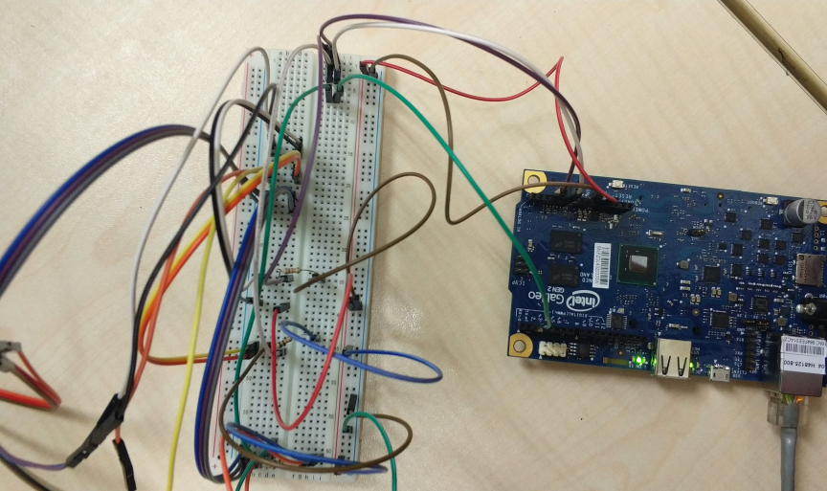

Figure 12: Diagram of testbed’s processing unit (Corak et al., 2018)

### Research paper II

In research from Moraes et al. (2019) titled ‘Performance Comparison of IoT Communication Protocols’, authors conducted two experiments to evaluate the performance of IoT communication protocols that is AMQP, CoAP, and MQTT. Throughput, message size, and packet loss are among the measures at play. The authors emphasize the need of considering network failures during data transfer, as evidenced by the two experiments. Experiment I evaluate the performance of each protocol without taking into consideration network issues, but the Experiment II does. The experiments collected the same environmental data and employed the same sensors as Research Paper I (Corak et al., 2018) - temperature, humidity, and light, with a motion sensor added. The difference between the Experiment II and the Experiment I is that there are two communication paths accessible. As a result, if there is a transmission failure, the IoT application transfers the data to a different path. For the server, an Intel i3 CPU with 8GB RAM and Ubuntu 18.04 is used, as well as a Raspberry Pi 3 Model B to connect sensors. The "Mosquitto", "RabbitMQ", and "CoAPthon3" open-source implementations for MQTT, AMQP, and CoAP are used. For both tests with minimal throughput and message size, the CoAP protocol produced the best performance, followed by MQTT. CoAP is also better at maximising network capacity and has packet loss comparable to MQTT, according to the authors.

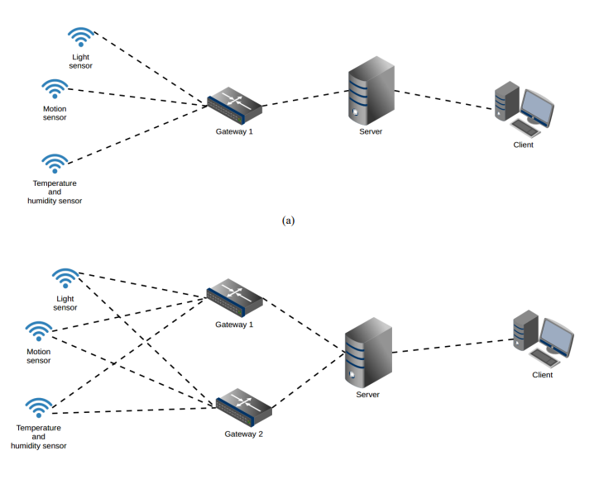

*(a)*



*(b)*

Figure 13: Topology for (a) Experiment I and (b) Experiment II (Moraes et al., 2019)

### Research paper III

Pohl et al. (2018) compare performance of the protocols AMQP, MQTT and XMPP in their study titled ‘Performance Evaluation of Application Layer Protocols for The Internet-Of-Things’. The authors propose a testbed that includes bandwidth utilisation, reliability, latency, and throughput for protocol characteristics. The authors employed the PubSub architecture, with three Raspberry Pi 3 Model B serving as sensor gateway, broker, and client, and a TP-Link TL-SF1005D ethernet switch connecting them to create a local area network (LAN).

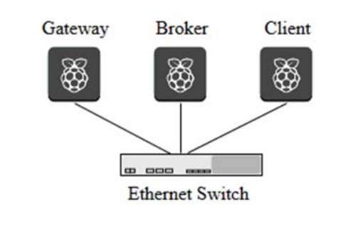

Figure 14: Diagram of hardware used for the testbed (Pohl et al., 2018)

All three protocols, MQTT, XMPP, and AMQP, are implemented using open-source Python 2.75 libraries in the gateway and client. The Paho version 1.3.06 library is used for MQTT, while SleekXMPP is used for XMPPP. Pika is also used to implement AMQP. The open-source MQTT and AMQP implementations "Mosquitto" and "RabbitMQ" are utilised. They get to the conclusion that MQTT performs best in terms of bandwidth utilisation, reliability, latency, and throughput.

### Research paper IV

Mijovic et al. (2016) experimentally evaluated the performance of IoT protocols, that are MQTT, WebSocket and CoAP. Protocol efficiency, which is directly connected to overhead, and average Round Trip Time (RTT) are the metrics at hand. The study is titled ‘Comparing Application Layer Protocols for The Internet of Things via Experimentation’. The authors conduct two experiments using two separate scenarios: a LAN scenario and an IoT scenario. The Nucleo-F411RE development board from STMicroelectronics was utilised, which has 512 kB of flash memory and 128 kB of RAM, as well as Arduino and Morpho connectors. Figure 2.3.4-1 below shows how the Nucleo board is linked to an Access Point (AP) through an ESP8266 module.

The server employed Libcoap, Tornado, and Mosquitto for CoAP, WebSockets, and MQTT, respectively, in terms of software. According to the findings, changing the network setup from a LAN to an IoT network has no effect on protocol efficiency. In an IoT scenario, however, the average RTT is substantially greater. The findings also revealed that, in comparison to the other protocols, CoAP has the maximum efficiency, whereas MQTT with QoS1 has both the lowest efficiency and the largest RTT.

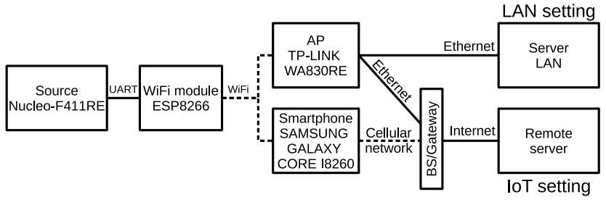

Figure 15: Experimental setup (Mijovic et al., 2016)

## Summary of Research Papers Reviewed

Table ‑: Summary of Research Papers Reviewed

|  |  |  |  |  |  |  |
| --- | --- | --- | --- | --- | --- | --- |
| **Features**  **Authors** | **Protocols** | **Hardware Used** | **Software Used** | **Metrics** | **Purpose(s)** | **Results** |
| Research Paper I Corak et al. (2018) | CoAP, MQTT, XMPP | * Intel Galileo Gen 2 board * ASUS Laptop (Intel Core i7-6700HQ CPU 2.60GHz, 4 GB RAM, Windows 64bit OS) | * CoAP-simple-library * Pubsubclient * XMPPArduino * Mosquitto * Openfire | Packet creation time and packet transmission time | Compare the performances of a set of well-known IoT communication protocols, namely CoAP, MQTT and XMPP in a real-world testbed. | XMPP is worse than other protocols in both metrics and MQTT and CoAP perform almost equally. |
| Research Paper II Moraes et al. (2019) | AMQP, CoAP, and MQTT | * Raspberry Pi 3 Model B * Intel i3 CPU, 8GB RAM and Ubuntu 18.04. | * Mosquitto * RabbitMQ * CoAPthon3 | Throughput, message size, and packet loss | Presents a performance evaluation of AMQP, CoAP, and MQTT with two experiments, one with network failure considerations and one does not | CoAP protocol obtained the best results, followed by MQTT. |
| Research Paper III Pohl et al. (2018) | AMQP, CoAP, and MQTT | * Three Raspberry Pi 3 Model B * TP-Link TL-SF1005D (Ethernet Switch) | * Python 2.7 * Paho version 1.3.0 library * MIT licensed library SleekXMPP version 1.3.2 * Pika version 0.11.0 * Mosquitto * ejabberd version 16.09 * RabbitMQ | Bandwidth usage, reliability, latency and throughput | Evaluate IoT protocols that are suitable for the use-case of monitoring in the field of business applications. | All protocols showed the same reliability. In all other categories, XMPP shows worse results than AMQP and MQTT. Moreover, MQTT shows better results than AMQP regarding the bandwidth usage and the message throughput. The results at the characteristic latency is equal for both protocols |
| Research Paper IV Mijovic et al. (2016) | CoAP, WebSocket and MQTT | * Nucleo-F411RE development board * Arduino and Morpho connectors * Access Point (AP) * ESP8266 module | * Libcoap * Tornado * Mosquitto | Protocol efficiency and the average RTT | Perform an experimental approach in performance evaluation of CoAP, WebSocket and MQTT with two scenarios:   * LAN setting * IoT setting (connected to Internet) – more realistic | Protocol efficiency does not change by changing the network setting, from LAN to an IoT network.  Average RTT is higher in the IoT setting.  CoAP achieves the highest efficiency  MQTT with QoS1 has both the lowest efficiency and the highest RTT. |

## Proposed Solution/ Further Project

The purpose of this project is to measure the different metrics of application layer protocols CoAP, MQTT and AMQP, such as bandwidth usage, latency, and throughput. For latency, values were calculated as a round-trip time (RTT) from the client node. The performance analysis is done by simulation using GNS3 instead of using hardware like papers reviewed above. The topology chosen is discussed in Chapter 4. Simulation is only done in LAN environment.

***Metric Measurement/Equation***

The main goal of this project is to analyse performance analysis of three specific protocols: CoAP, MQTT & AMQP in terms of bandwidth usage, latency, and throughput. The metrics that are to be analysed and also their respective explanations are as below:

1. Bandwidth Usage

Protocol efficiency is a standard metric for measuring the bandwidth consumed by an IoT protocol. It is defined as the ratio of network packets delivered to transport a message to the information that this message should transfer. The detected number of extra bytes transferred across the network enables a statement about the bandwidth required by a protocol to be made. Tool used to measure bandwidth is Jperf as it tests the bandwidth between two points on a network; in our case – server and client.

1. Latency

The summation of all possible delays encountered by a packet during data transmission is referred to as network latency. Latency is commonly expressed as round-trip time (RTT) and measured in milliseconds (ms). A ping is a command-line tool that returns a request off a server and measures the time it takes to reach a user device.

1. Throughput

Throughput is the quantity of data that can be transferred and received in a given time period. This means that the throughput metric computes the average rate at which sent messages reach at their intended destination.

The formula for calculating throughput is:

$$I=R×T$$

Where I stand for inventory, R stands for throughput rate, and T stands for time. Because the intended end result is throughput rate, or R, the formula may be rearranged by solving for R as follows:

$$R=I/T$$

Tools to measure throughput include iPerf and pingb that are run on Command Prompt.

## Conclusion

This chapter includes a much more detailed overview of the three IoT protocols used that is CoAP, MQTT and AMQP as well as critical review based on past research papers. In the critical review section, a hypothetical study of past studies on performance analysis and evaluation of IoT protocols is mentioned.

# PROJECT METHODOLOGY

## Introduction

This chapter go through the project methodology and how it is carried out. This chapter include the framework of the selected methodology – Waterfall model, as well as a full description of each component of the framework. The framework is essential to ensure that the project is carried out and completed within the timeframe specified. Following that, it provides present project milestones and a Gantt Chart to demonstrate progress and tasks to be completed within the period.

## Methodology

It is vital to pick the project methodology to use so that the project may be completed within the period set. A methodology is a set of methods or procedures for dealing problems using methodical approaches. Thus, methodology is utilised to examine theoretical techniques that demonstrate how the system may achieve and meet the project's objectives. The chosen methodology is the Waterfall model that is a sequential approach of the Systems Development Life Cycle (SDLC). This methodological process works like a waterfall through all phases of a project (requirement analysis, system design, implementation, testing, deployment, and maintenance), with each stage entirely finishing up before moving on to the next. Figure 3.2-1 depicts the structure of the methodological model employed in this project.

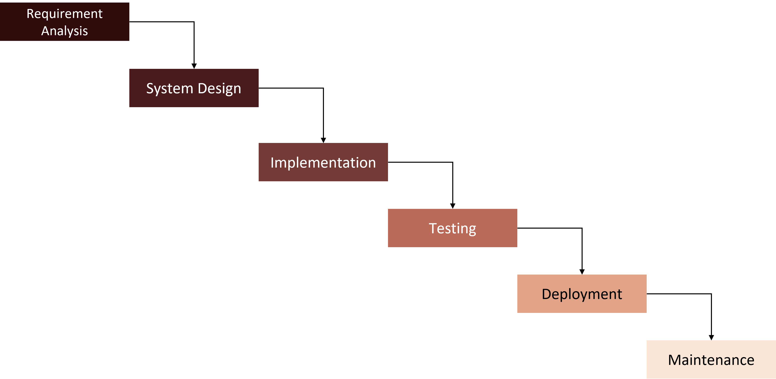

Figure 16 Waterfall Model

### Requirement Analysis

#### Hardware Requirement

A laptop is used as a workstation for all tasks, from researching to documenting. The laptop specifications are shown in the table below.

Table 3.2‑1: Hardware Requirement

|  |  |
| --- | --- |
| **Specification** | **Description** |
| Processor Type | AMD Ryzen 5 5600U with Radeon Graphics 2.30 GHz |
| Operating System | Windows 11 Version 21H2 |
| Operating System Type | 64-bit operating system, x64-based processor |
| RAM | 8.00 GB (7.35 GB usable) |
| Storage | 476 GB |
| Display Resolution | 1920 x 1200 |

#### Software Requirement

This project's development includes the usage of some software. The software used in this project is listed in the table below.

Table 3.2‑2: Software Requirement

|  |  |
| --- | --- |
| **Software** | **Description** |
| Windows 10 | An environment of operating system used for project execution. |
| GNS3 | Software used to execute the simulation/experiment based on the topology selected. |
| VMware Workstation Pro | Software to run virtual machines |
| Wireshark | Capture network traffic for analysing purpose. |
| Microsoft Word 365 | Software used to complete the project reporting and documentation. |
| Microsoft Excel 365 | Software used to sort the data according to attributes and instances, also to create graph. |
| Microsoft PowerPoint 365 | Software used to create charts or framework. |

### System Design

This phase aims to design the topology that is going to be used in simulation in GNS3. The design system helps specify hardware and system requirements, and it helps to define the overall input and output of the system. New topology is developed based on the architecture of CoAP, MQTT and AMQP protocols that consists of server and clients. This topology is then simulated in GNS3 to measure three metrics – bandwidth utilisation, latency, and throughput.

### Implementation

The goal of this phase to determine how the topology from previous phase are implemented. One experiment is carried out which take into account the MQTT, AMQP, and CoAP protocols. The metrics that have been chosen include bandwidth utilisation, latency, and throughput. The data collected during this phase is analysed. This stage necessitates significant attention because it determines the project's outcome and result. Figure 3.2-2 below depicts how the data is processed, and the final result is obtained during the project.

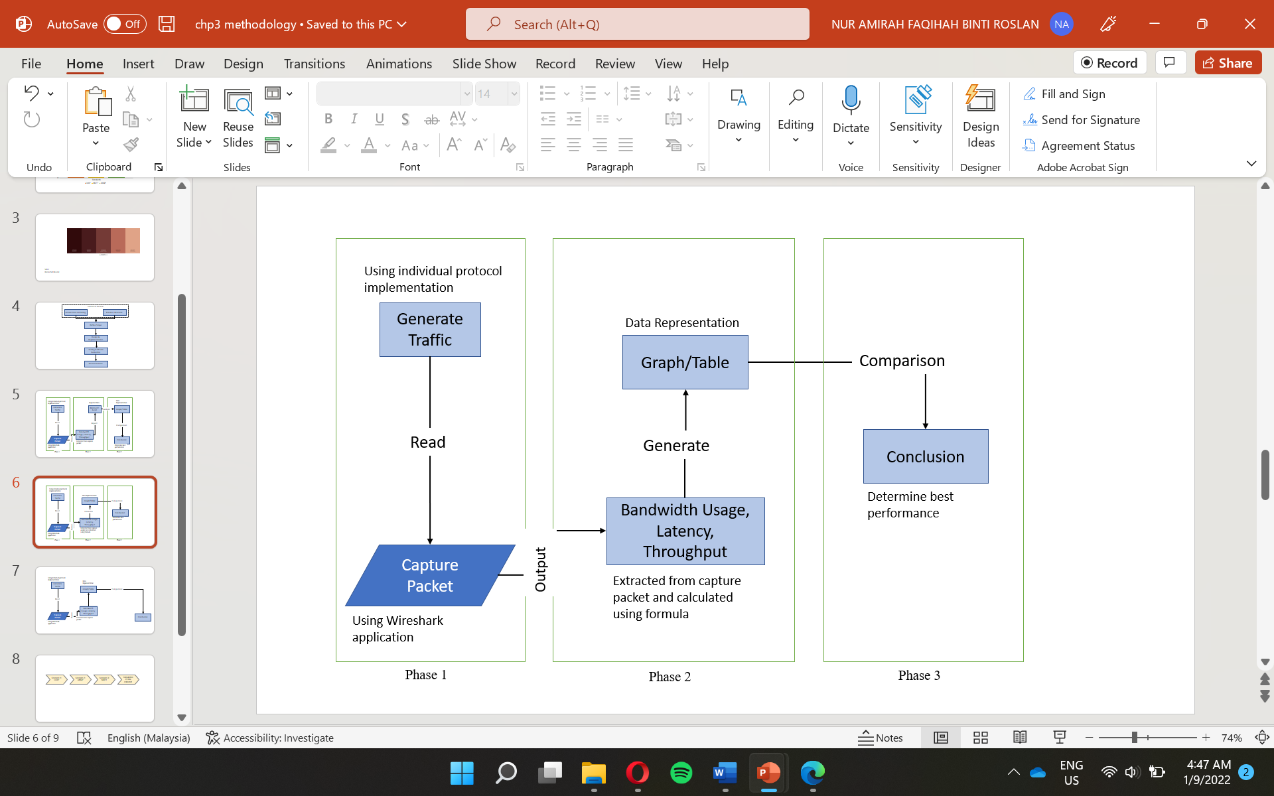

Figure 17: Data Processing and Obtaining Result

### Testing

The performance of each protocol is monitored at different topologies during this phase. To forecast the deployment phase, the metrics are studied and compared to past research.

### Deployment

When all data from all chosen topologies has been collected, the results are presented and analysed referencing previous research papers. A critical review is performed from the findings. Graphs are plotted for each metrics – bandwidth usage, latency and throughput that includes all topologies run. Table of comparison for each protocol and metrics are also provided. Examples for both graphs and table are portrayed in Figure 3.2-3 and Table 3.2-2 respectively.

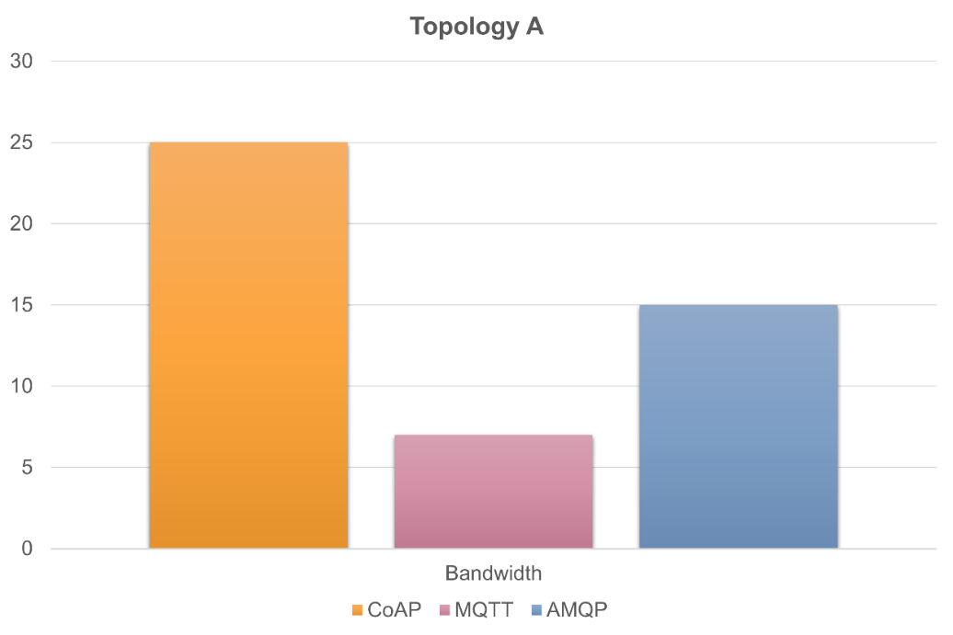

Figure 18: Example of Graph that compares three protocols based on Bandwidth Utilisation

Table 3.2‑3: Example of Comparison Table generated after analysis of data is finished

|  |  |  |  |
| --- | --- | --- | --- |
| **Protocols**  **Metrics** | **CoAP** | **MQTT** | **AMQP** |
| Bandwidth Usage | *[value]* | *[value]* | *[value]* |
| Latency | *[value]* | *[value]* | *[value]* |
| Throughput | *[value]* | *[value]* | *[value]* |

### Maintenance

During this phase, if the testing fails, some maintenance is made to determine the cause and resolve the problem. To locate the mistake, every configuration made to measure the metrics are examined. The testing stage then is performed several times until a better result is attained. As a result, the maintenance phase occurs during testing and can also be applied if the project encounters an error. Recommendations to improve IoT performance may be made based on the simulation results. This section also discusses the difficulties encountered during the implementation process, from setting up the environment to gathering findings.

## Project Schedule and Milestones

### Project Milestones

A milestone is a project marker that denotes a shift or stage of progress. Thus, project milestones is essential in keeping track of upcoming events or goals across the timeline.

|  |  |  |
| --- | --- | --- |
| **Week** | **Phase** | **Activity** |
| 1-6 | Requirement Analysis | * Gather information regarding IoT protocol. * Studies on related work and previous research of performance analysis of IoT protocol. * Analyse the methods used by previous researchers to do their study. * Studies on hardware and software used to run the experiment. |
| 7-14 | System Design | * Information collection and analysis. * Project design – where to implement and topology selection. * Project demonstration and report submission to supervisor and evaluator. |
| ***SEM BREAK*** | | |
| 15-18 | Implementation | * Installation of GNS3 and ISO used. * Setup selected topology in simulator, GNS3. * Configure nodes, switches, servers based on the needs. * Configure topology so it can measure the chosen metrics (bandwidth utilisation, latency, and throughput) * Integrate VMware with topology in GNS3 |
| 19-22 | Testing | * Test the configuration done. * Monitor performance for each protocol at different topology. |
| 23-25 | Deployment | * Describe the results gain from the simulation. * Critical review of findings from the simulation done. |
| 26-28 | Maintenance | * Provide recommendation to improve IoT performance. * Project demonstration and final report submission to supervisor and evaluator. |

### Project Gantt Chart

Gantt Charts provide a thorough overview of the project from start to finish, as well as all the activities required to complete the project. It aids in demonstrating how far the tasks have progressed.

|  |  |  |  |  |  |  |  |  |  |  |  |  |  |  |  |  |  |  |  |  |  |  |  |  |  |  |  |  |
| --- | --- | --- | --- | --- | --- | --- | --- | --- | --- | --- | --- | --- | --- | --- | --- | --- | --- | --- | --- | --- | --- | --- | --- | --- | --- | --- | --- | --- |
| **PHASE** | **WEEK** | | | | | | | | | | | | | | | | | | | | | | | | | | | |
| 1 | 2 | 3 | 4 | 5 | 6 | 7 | 8 | 9 | 10 | 11 | 12 | 13 | 14 | 15 | 16 | 17 | 18 | 19 | 20 | 21 | 22 | 23 | 24 | 25 | 26 | 27 | 28 |
| Requirement Analysis |  |  |  |  |  |  |  |  |  |  |  |  |  |  |  |  |  |  |  |  |  |  |  |  |  |  |  |  |
| System Design |  |  |  |  |  |  |  |  |  |  |  |  |  |  |  |  |  |  |  |  |  |  |  |  |  |  |  |  |
| Implementation |  |  |  |  |  |  |  |  |  |  |  |  |  |  |  |  |  |  |  |  |  |  |  |  |  |  |  |  |
| Testing |  |  |  |  |  |  |  |  |  |  |  |  |  |  |  |  |  |  |  |  |  |  |  |  |  |  |  |  |
| Deployment |  |  |  |  |  |  |  |  |  |  |  |  |  |  |  |  |  |  |  |  |  |  |  |  |  |  |  |  |
| Maintenance |  |  |  |  |  |  |  |  |  |  |  |  |  |  |  |  |  |  |  |  |  |  |  |  |  |  |  |  |

## Conclusion

To conclude, the project methodology includes all six phases in Waterfall model. This chapter is crucial in ensuring project’s success and that the project progressed smoothly. Gantt charts and project milestones are also necessary to guarantee that this project stays on track. In the next chapter, the detailed design to run the experiment to evaluate IoT protocols’ performance is discussed.

# ANALYSIS AND DESIGN

## Introduction

This chapter briefly outline the project's design that is going to be implemented in order to make the project clearer. This chapter provides logical and physical design with explanation. Possible scenarios in this project are also stated. In addition, the simulation's topology design is discussed during this phase. As a result, this chapter provides a good understanding of the specific topology that is implemented in the next chapter.

## Network System Architecture

This project is carried out under the same network environment, refer Figure 4.2-1 below which consider CoAP, MQTT and AMQP protocol. The server and clients PCs both run on Ubuntu. Clients send message to Server. The server and clients are linked directly to ethernet switch which act as gateway.

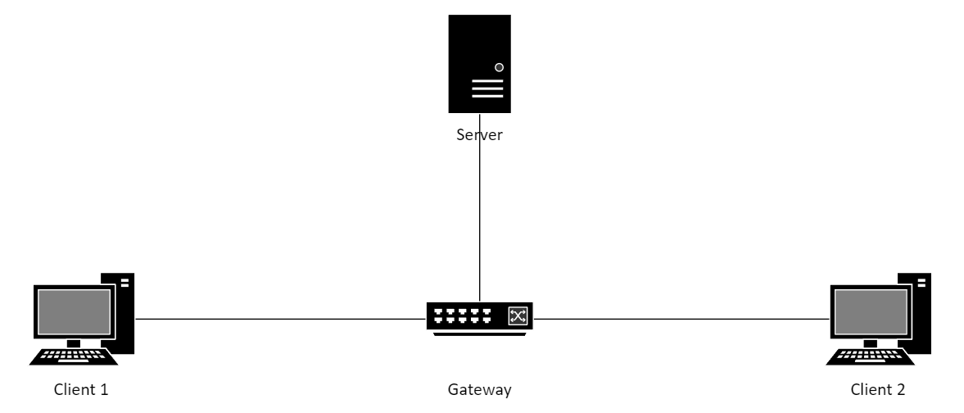

Figure 19: Network System Architecture

### Client

Ubuntu 20.04 is installed in Client PC. Server exchange data between client PCs. The publish-subscribe approach is used by MQTT and AMQP protocols, which means that Client 2 act as publisher and Client 2 act as subscriber. CoAP is a client-server protocol in which the client delivers a GET or PUT request to the server.

### Server

Since of the changes made after the release of Ubuntu 18.04, such as the migration to newer versions of the Linux Kernel and Gnome, Ubuntu 20.04 LTS was chosen as the server because it is stable, consistent, and familiar. Ubuntu is a Debian-based Linux operating system for PCs, tablets, and smartphones (Ubuntu Touch edition), as well as network servers (Ubuntu Server edition), that can be installed on physical or virtual servers. Ubuntu Server additionally allows you to assign "super user" responsibilities to make network administration easier. The server operates as the broker in the publish-subscribe approach used by MQTT and AMQP protocols. The broker is a crucial component of the MQTT and AMQP protocol implementation since it receives messages from publishers and routes them to subscribers.

### Switch

The server and client are connected via an ethernet switch. In an Ethernet LAN, Ethernet switches connect devices such as computers and servers so that they may communicate with one another.

## Logical & Physical Design

### Logical Design

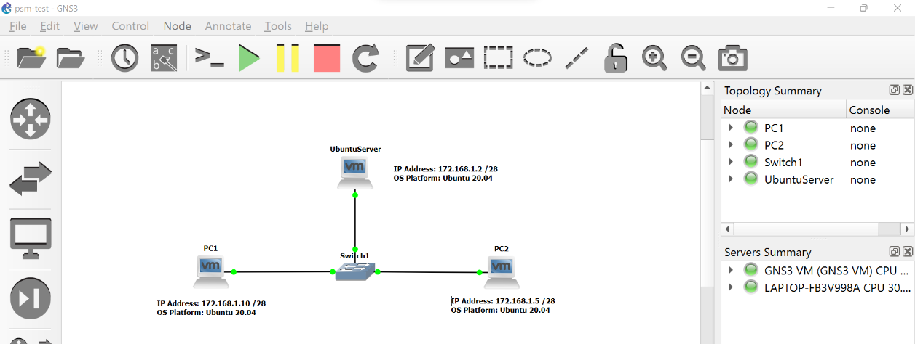

Figure 20: Logical Design

Logical design is pictorial representation of how the network devices are connected with each other. It also includes the device addressing, operating system used, and selected protocol algorithm used in this project. As illustrated in Figure 4.3-1 above, server and clients are linked directly to ethernet switch which act as gateway. Ubuntu 20.04 LTS is installed at both server and client PCs. The IPv4 addresses are set manually at each device. The server Internet Protocol (IP) address is 172.168.1.2, IP address for Client 1 is 172.168.1.10 and for Client 2 is 172.168.1.5. All the PCs and Server connected in the LAN.

### Physical Design



Figure 21: Physical Design

The feature and recommended usage of the technologies and selected equipment to implement the design are described in the physical design, refer Figure 4.3-2 above. As indicated in the preceding paragraph, data is shared between a server and clients.

There are different implementations for clients and server for each protocol due to its individual architecture. Further explanation of the implementation is provided in the next section. But the general idea is, for server and client to connect directly to each other, the client needs enter the server's IP address. After the server and client have established a connection, packets are sent between them.

## Possible Scenario

There is one testbed conducted in this project. This testbed includes three different scenarios. Each scenario represents each IoT protocol and are discussed at the following paragraph. Each scenario conducted between two workstations (Clients) and server that is connected via Ethernet switch on the same network. Table 4.4-1 below shows the possible scenarios that is implemented in this project.

Table ‑: Possible Scenarios

|  |  |  |  |
| --- | --- | --- | --- |
| IoT Protocol | CoAP | AMQP | MQTT |
| Scenario | 1 | 2 | 3 |

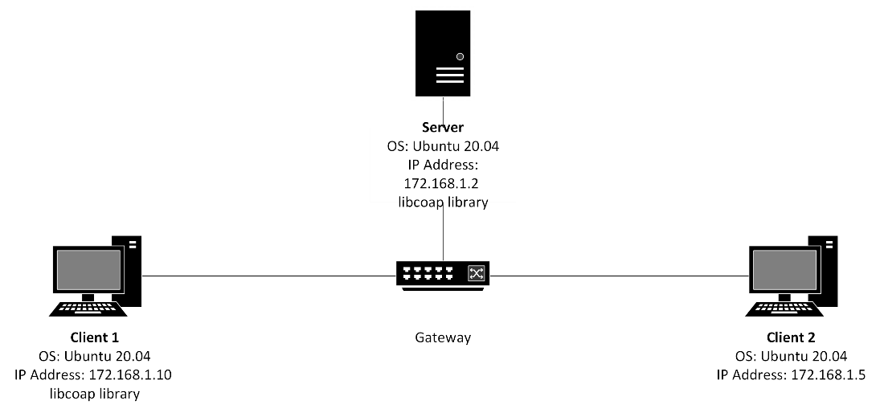

Figure 22: Scenario 1: CoAP

In Scenario 1 for CoAP protocol, libcoap library is installed at both Server and PC1. libcoap is an open-source C-library which contained an application server running at coap-server and a multi-purpose command client running at coap-client. Client PC1 send GET request to request resource from the Server at coap://172.168.1.2. At Server, a response message is sent to Client PC1 where the resource requested is displayed.

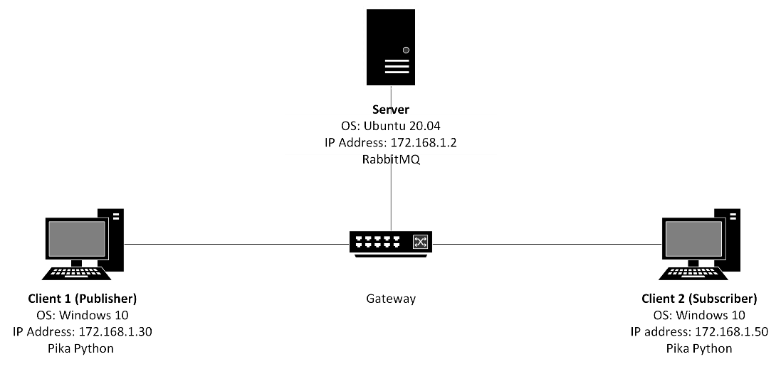

Figure 23: Scenario 2: AMQP

The second scenario is conducted using AMQP protocol. For this scenario, RabbitMQ is installed at the server. RabbitMQ is a message broker that implements Advanced Message Queuing Protocol (AMQP). It provides client libraries for major programming languages. In Client PCs, message is sent and received using the Pika Python client. After establishing a connection to RabbitMQ Server, publisher (Client PC1) sends a single message to the queue. Subscriber (Client PC2) receive messages from the queue.

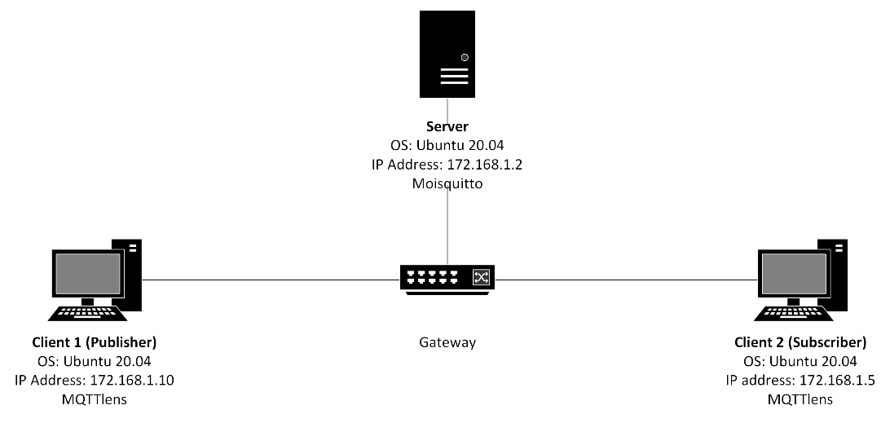

Figure 24: Scenario 3: MQTT

The third scenario is conducted using MQTT protocol. The adopted open-source implementation for MQTT is Mosquitto. Mosquitto is installed at the server as it acts as broker in MQTT protocol. MQTT Lens is installed at both Publisher and Subscriber PCs. MQTT Lens is a Chrome browser add-on that connects to a MQTT broker and lets clients publish messages to the broker, subscribe to MQTT topics, and receive messages. Publisher connects to a MQTT broker and publishes a message to a topic defined with MQTT Lens. Subscribers who are also connected to the broker and have subscribed to a certain subject defined by the Publisher get the MQTT message published by the Publisher.

During the test, the packets send through the network are captured using Wireshark. Based on this data, bandwidth usage, latency and throughput are monitored and analysed.

## Conclusion

To summarize, this chapter is vital as it contains the clear idea on how to develop the project, in this case, to analyse the performance of IoT protocol. The chapter goes through system architecture, physical and logical design of the simulation and also includes the proper measurement of metrics. The upcoming phase, implementation phase, must be carried out using the analysis and design achieved in this chapter.

# IMPLEMENTATION

## Introduction

This chapter covers the implementation process of the project in detail. This chapter covers the software environment setup and its configuration management to make sure the project planned run smoothly and effectively. This project utilized GNS3 and VMware to run the simulation scenarios revised in Chapter 4. These scenarios are monitored, and packets are captured to be analysed. Aside from that, the implementation status shows the progress of each project component.

## Software Development Environment Setup

This section will provide a brief overview of the project’s environment. This project requires three PCs acting as server and clients, and Ethernet switch connecting them to create a local network (LAN) in GNS3 environment. Three virtual machines (VMs) are employed in a networked LAN environment during the implementation phase. All VMs have Ubuntu 20.04 installed as their operating system and are integrated with GNS3. CoAP, MQTT, and AMQP are three separate protocols that have three different implementation scenarios. For all protocols, 100 messages are sent from client to server.

Wireshark is a popular open-source network protocol analyser with several functions, including offline analysis, live packet capture, and tracking of network packets. Wireshark is used to capture packets sent between server and client PCs during implementation. These packets are then examined to determine the bandwidth, latency, and throughput of each protocol. These measured metrics are compared between the protocols to analyse its performance.

## Software Configuration Management

In this section, the configuration used to execute this project will be divided into three parts that includes three scenarios where each scenario is the protocols studied. All the codes for the scenarios are presented in each respective part.

### Scenario 1: CoAP

libcoap library is installed in both Client PC1 and Server. Start coap-server at Server (IP Address: 172.168.1.2). CoAP Server is keep alive to receive any CoAP messages on port 5683.

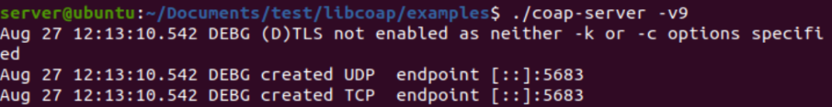

Figure : CoAP server running at Server

Start coap-client at PC1 (IP Adress: 172.168.1.10). CoAP client will send CoAP message to CoAP Server (IP Address: 172.168.1.2).

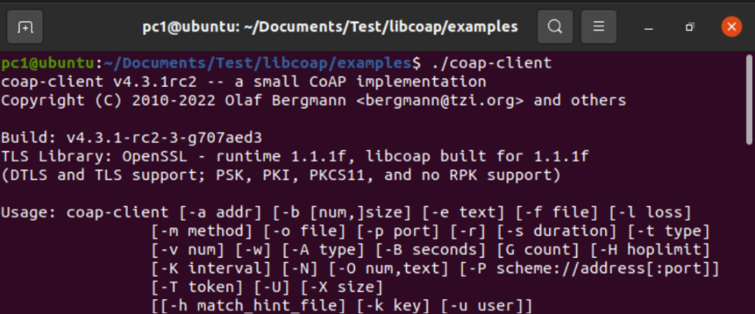

Figure : CoAP client running at PC1

The purpose of this scenario is to have CoAP messages send from Client PC to Server and get bandwidth, latency, and throughput of CoAP protocol to be analysed, thus simply GET messages are sufficient. PC1 sending CoAP GET message time to Server for 100 seconds. PC1 then get time information for 100 seconds from Server, which are displayed in the terminal.

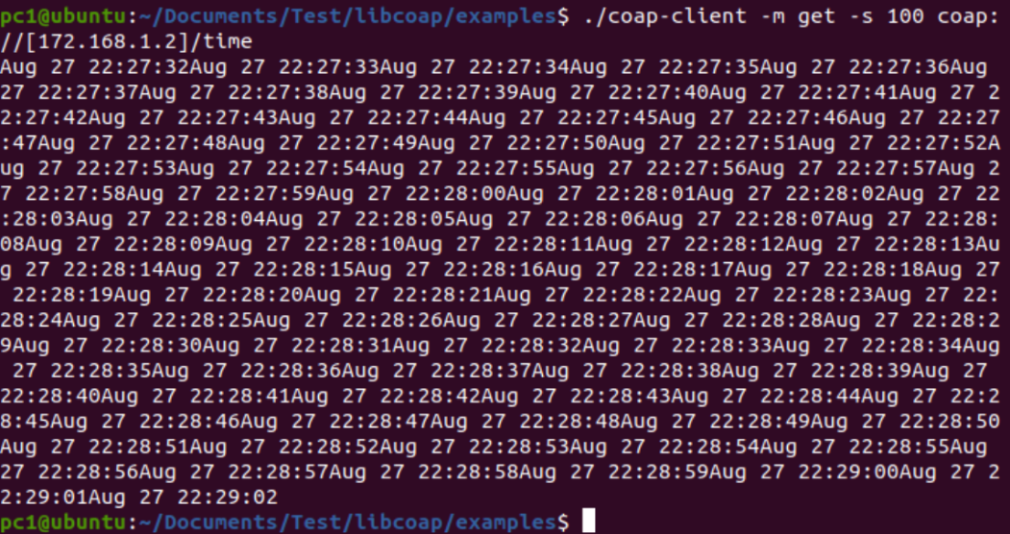

Figure : CoAP Client sending GET message

This means that the Server received 100 GET messages from PC1 requesting 'time' for 100 seconds. After that, the server responds to PC1 by sending the time requested for 100 seconds (100 times). Refer to Figure 28 to see the log for when PC1 sends a GET message to the server.

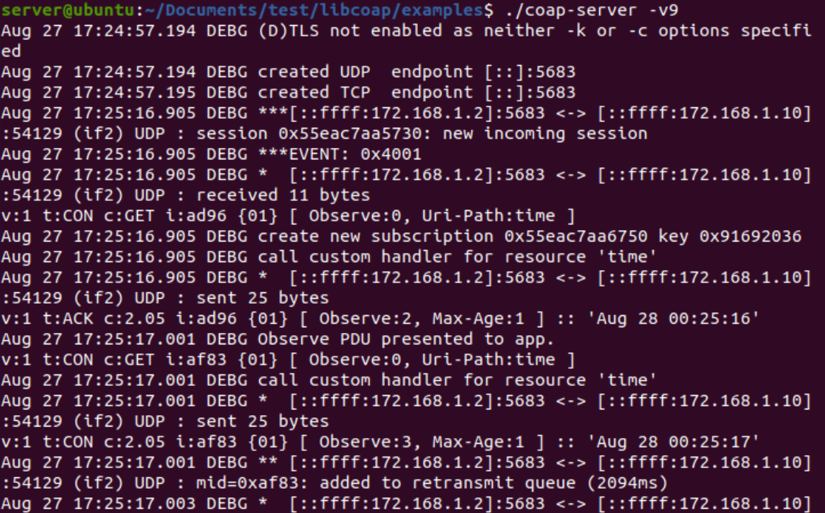

Figure : Server received CoAP messages from PC1

Packet is captured through Wireshark on Server side, started when client send the GET message statement and is stopped after the Server response to the message.

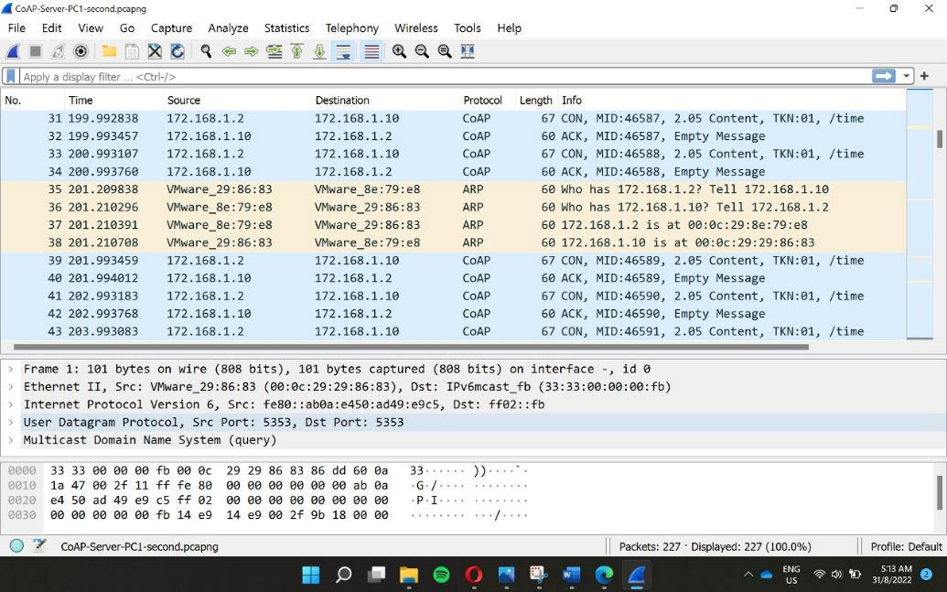

Figure : Wireshark Packet Capture (CoAP)

### Scenario 2: AMQP

RabbitMQ is a message-queueing software also known as a message broker and is installed at Server.

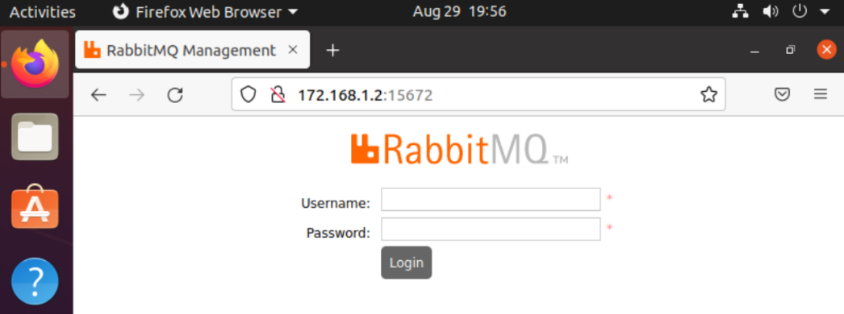

Figure : RabbitMQ installed in Server browser

In RabbitMQ, messages produced by publisher are pushed in Message Queue and they stay there until a subscriber connects to the broker and fetch those messages. To send and receive messages, pika Python is installed at both Client PCs. PC1 or publisher post 100 messages to AMQP broker that send them to PC2, subscriber. Figure 31 below is the Python code written to send 100 messages to the queue.

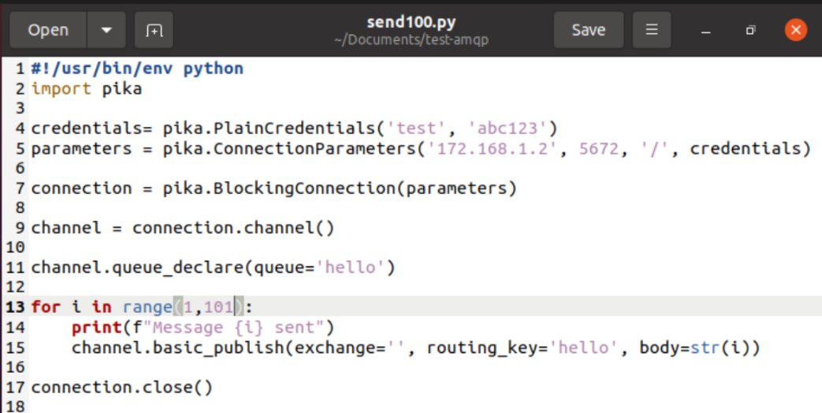

Figure : Python code for sending message

From the figure, line 4 is the username and password of RabbitMQ broker which is the Server. Line 5 and 7 is to establish the connection to broker with IP Address 172.168.1.2 and RabbitMQ default port, 567. The ‘/’ represent that the broker is on virtual host with username and password defined at credentials. Line 11 create a ‘hello’ queue to which the message will be delivered. Line 13 and 14 is to print 100 messages in PC1 terminal. A message in RabbitMQ can never be sent directly to the queue; it must always go through an exchange. Line 15 is used to publish messages using the default exchange, routing key specified as queue name 'hello,' and body is the i value which is number of messages sent from 1 to 100.

Figure 31 below is Python code written to receive 100 messages from the queue and print them on the screen. Again, first we need to connect to RabbitMQ server. The code responsible for connecting to Rabbit is the same as previously. Line 12 is to declare the queue ‘hello’ to make sure it exists. To receive messages from queue, subscribing a callback function to a queue is needed. Every time a message is receive; this callback function is called. In our case, the function will print the content of the messages that is the number 1 until 100. Line 17 is to tell RabbitMQ that this particular callback function should receive messages from our hello queue.

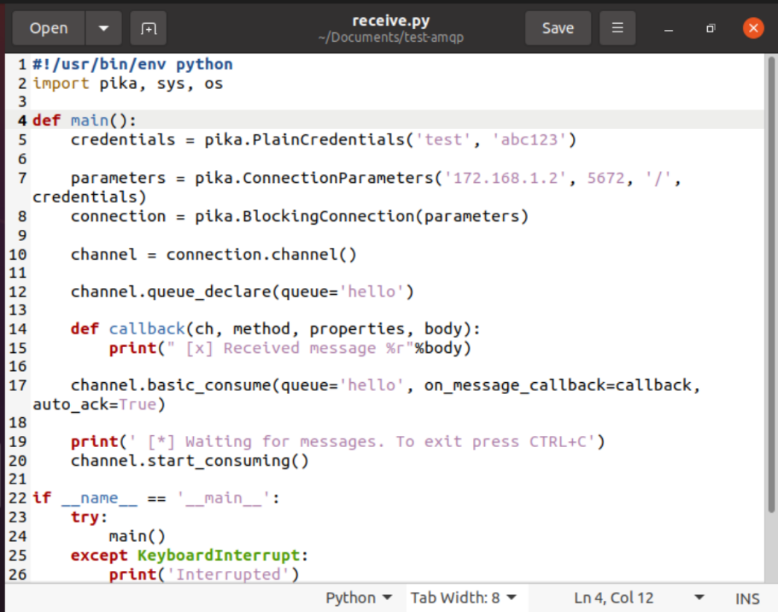

Figure : Python code for receiving message

RabbitMQ Management Interface on Server browser lets user monitor the server easily.

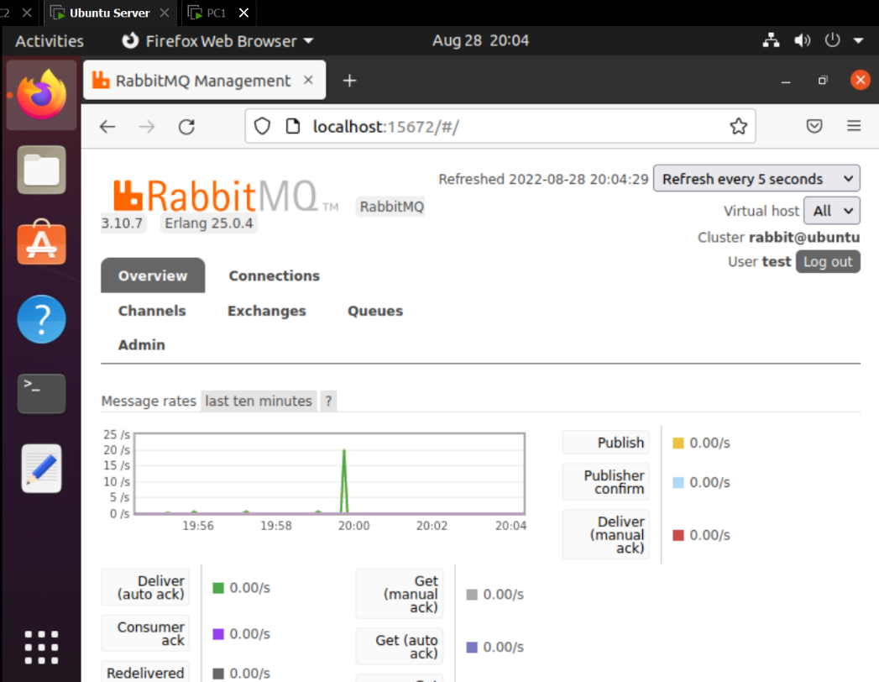

Figure : RabbitMQ Management Interface

Packet is captured through Wireshark on Server side, started when PC1 send the message and stopped when PC2 received all 100 messages.

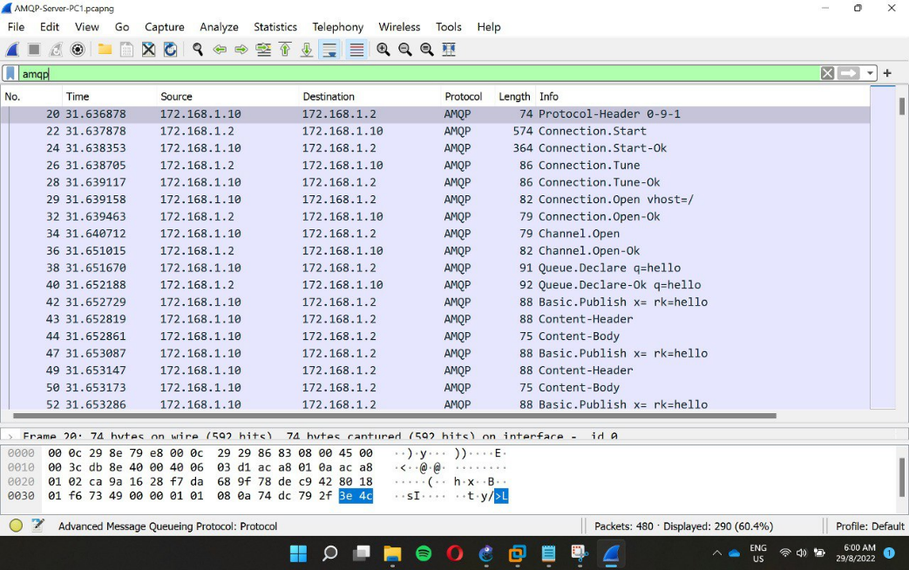

Figure : Wireshark Packet Capture (AMQP)

### Scenario 3: MQTT

The publisher/subscriber topology is supported by the Mosquitto application. Clients connect to the Mosquitto server in this approach, which functions as a broker to spread information to other clients who have subscribed to or are submitting messages to a topic. Mosquitto package is installed in the Server (172.168.1.2) and is loaded and active on port 1883.

Client PC1 (172.168.1.10) acts as the publisher who publish a topic and send message under the topic published. Client PC2 (172.168.1.5) is the subscriber who subscribed to a topic and received messages the instant publisher sends them. MQTT Lens is installed in both PCs to connect to broker, publish topics, receiving message and subscribe to topics.

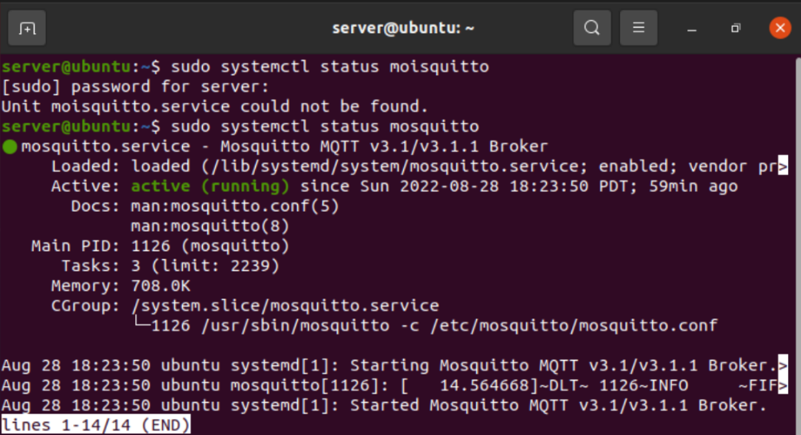

Figure : Moisquitto loaded and running

In both PCs, a new connection is added where the hostname is Mosquitto broker (172.168.1.2) and the port Mosquitto is running on. In PC1 who acts as a publisher, topic “mqtt/test” and message “hello” are set as shown in Figure 37. As shown in Figure 38, the topic published from publisher "mqtt/test" is subscribed in PC2 - subscriber. Every message sent by publisher is received by clients who subscribed to the topic.

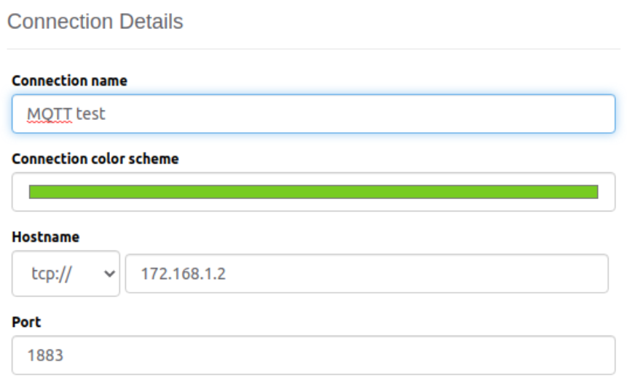

Figure : Connection details

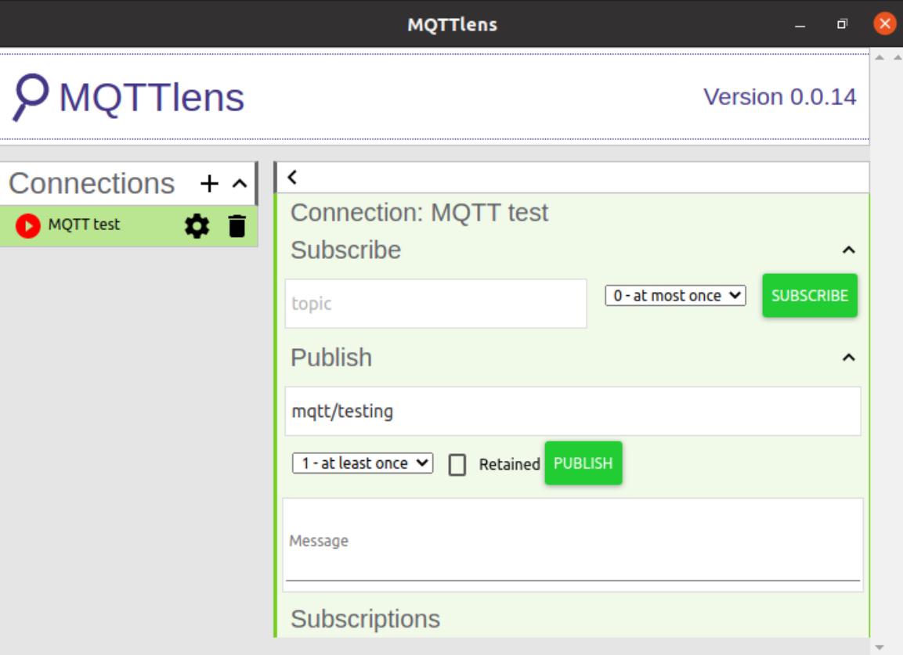

Figure : PC1 MQTTlens interface

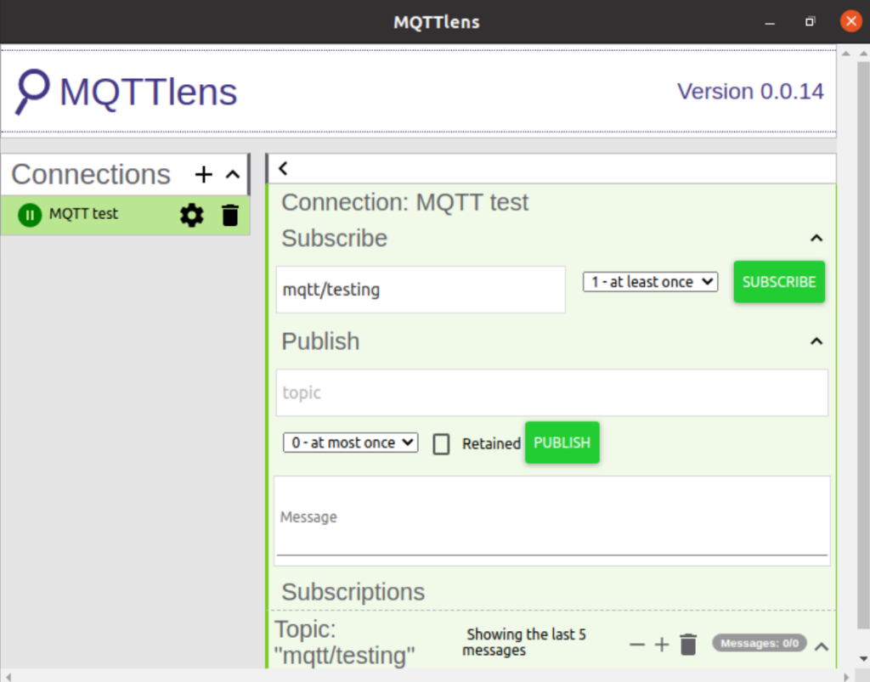

Figure : PC2 MQTTlens interface

PC1 sent 100 messages under the topic “mqtt/testing” where PC2 received those messages as shown in Figure 39.

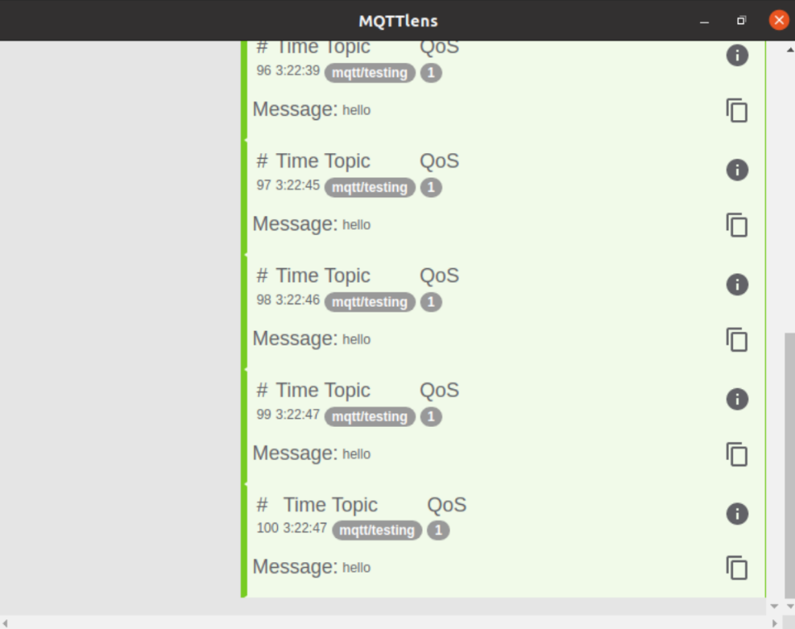

Figure : PC2 received 100 messages from PC1

Packet is captured through Wireshark on Server side, started when PC1 publish a topic and stopped when PC2 received all 100 messages sent under the same topic.

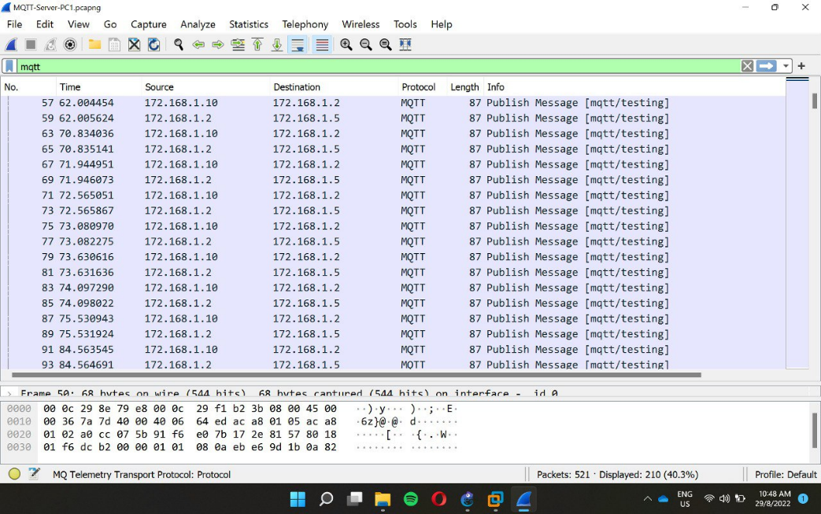

Figure : Wireshark Packet Capture (MQTT)

## Collected Data (Bandwidth Usage, Latency and Throughput)

The main outcome of this chapter is to find out the bandwidth usage, latency and throughput of each protocol based on client and server connections. In Wireshark, the display filter is set to the protocols studied and the value of their respective bandwidth usage, latency and throughput are recorded. In Wireshark, Protocol Hierarchy under the Statistics tab is used to examine the bandwidth usage. The amount of bandwidth available in a network determines how many packets can be transmitted and received between devices at a time. This screen will give you a breakdown of bandwidth by protocol by referring the Bits/s column. Figures 43, 44 and 45 below show the Protocol Hierarchy Statistics for CoAP, AMQP and MQTT.

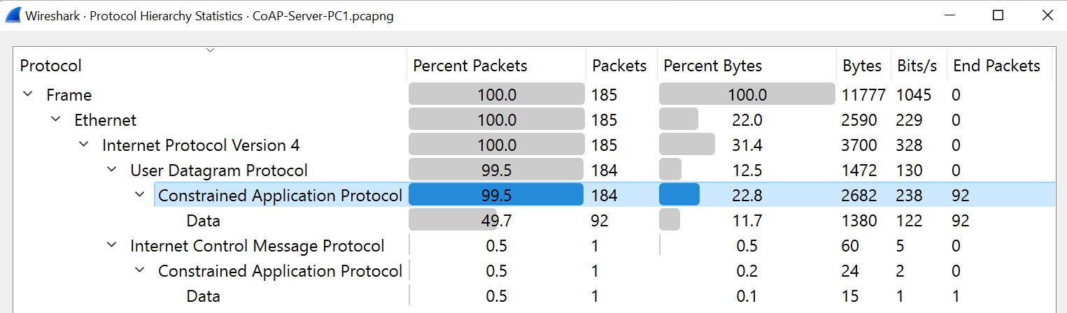

Figure : Protocol Hierarchy for CoAP

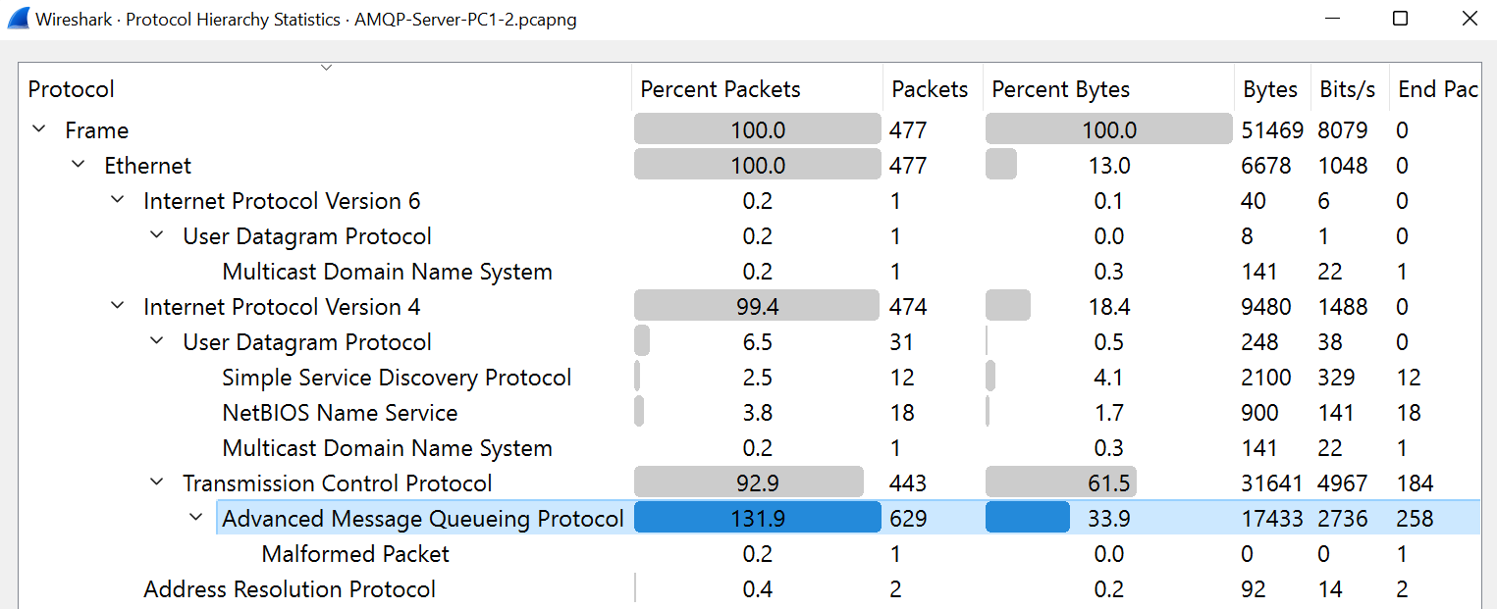

Figure : Protocol Hierarchy for AMQP

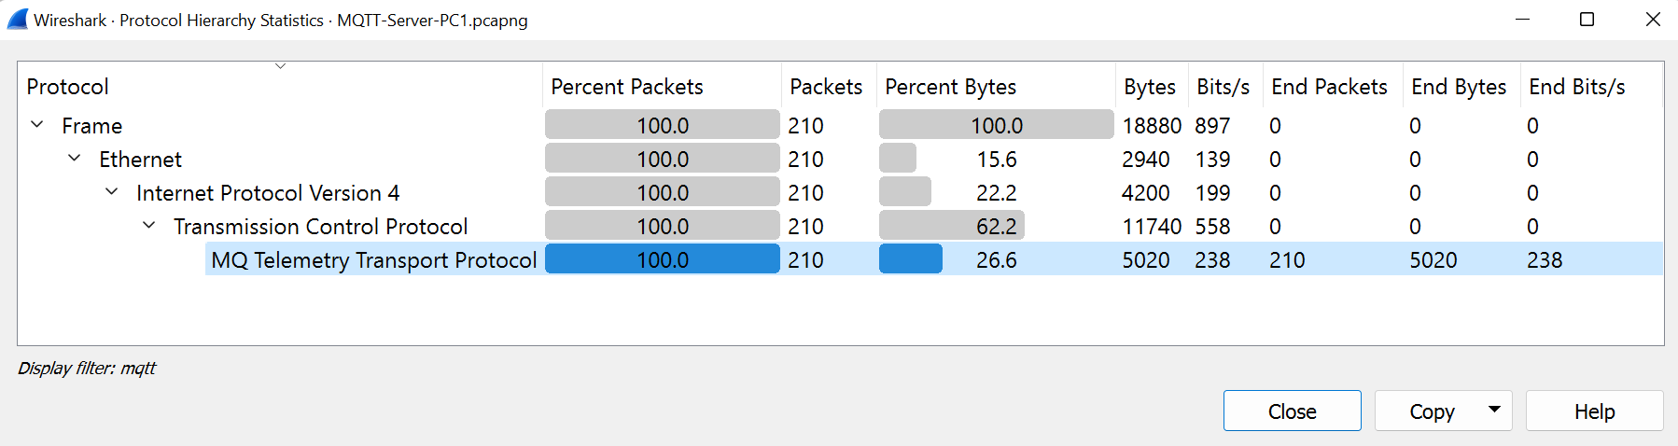

Figure : Protocol Hierarchy for MQTT

Latency is described as the amount of time it takes for a message or packet to get from its origin to its destination. It is measured in units of time – s (second). In our case, the amount of time it takes for CoAP, MQTT and AMQP packets to get from clients to server. Latency is measured in equation as follow (Omomule et al., 2019):

$$Latency= \frac{Packet length (bit) }{Link bandwidth (bit/s)}$$

Packet length information can be found in Packet Lengths under Statistics tab, which is displayed in bytes, refer Figure 44. Average packet length is used in this study and is converted into bits to calculate latency using the equation above.

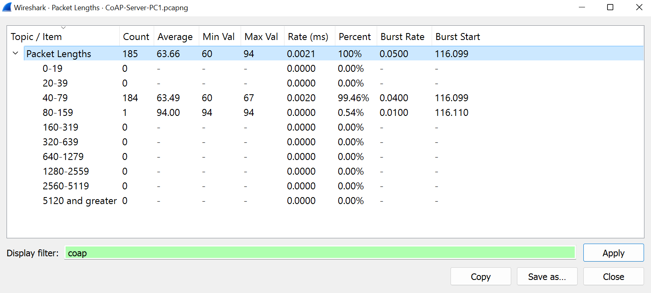

Figure : Packet Length for CoAP

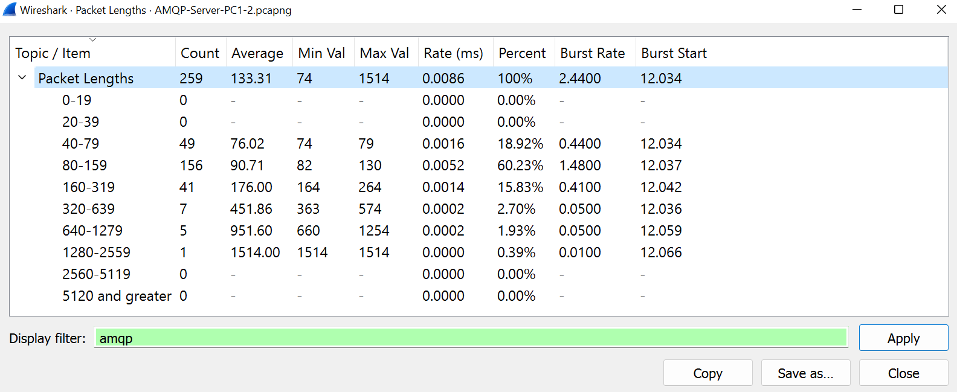

Figure : Packet Length for AMQP

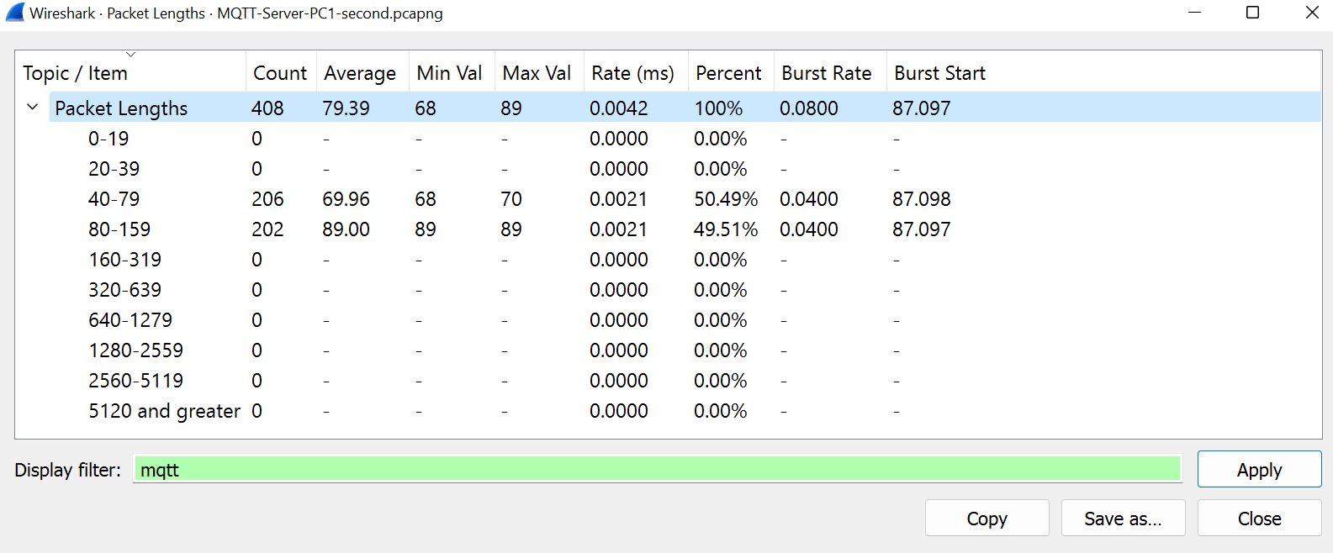

Figure : Packet Length for MQTT

Throughput expresses the amount of data transported across a network per unit of time. It is the rate at which data packets or messages are successfully delivered to a recipient. It is usually expressed in bits per second (bps), bytes per second (Bps) or packets per second (pps) (Omomule et al., 2019). Referring to Nugroho, Irfan and Faruq (2019), throughput is presented as equation below:

$$Throughput= \frac{Total packets send (p) }{Time of data send (s)}$$

The data needed to calculate throughput is found in Conversations window under Statistics tab in Wireshark, where Total Bytes and duration of the UDP or TCP stream limited to the display filter, the three protocols studied, is stated.

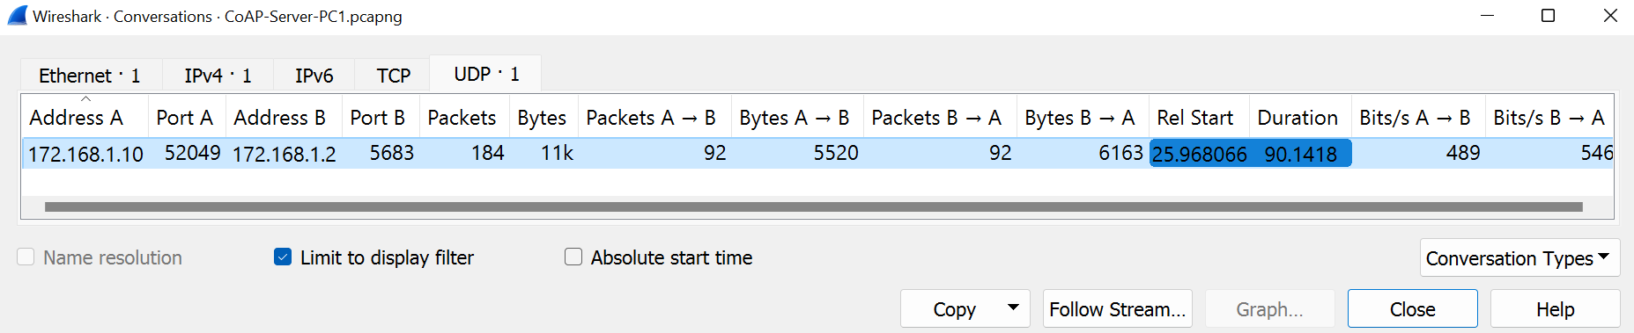

Figure : Conversations Statistics for CoAP

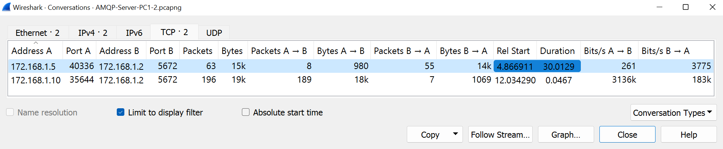

Figure : Conversations Statistics for AMQP

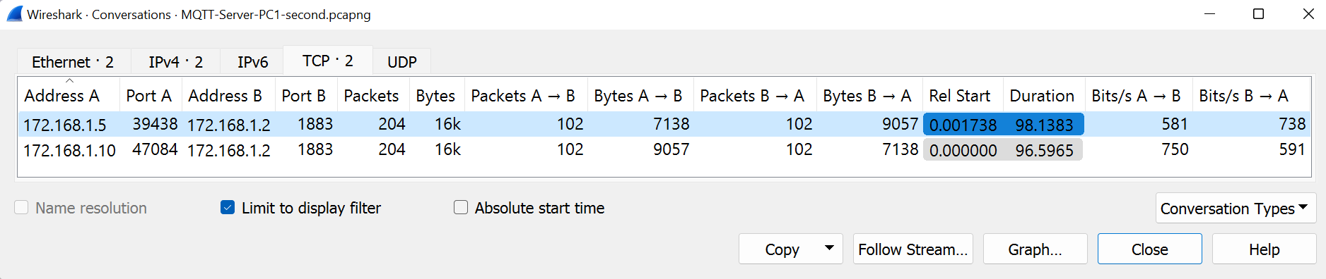

Figure : Conversations Statistics for MQTT

Table ‑ below shows the value of bandwidth usage, latency and throughput respective to the three protocols studied.

Table ‑: Comparison Table from Collected Data

|  |  |  |  |
| --- | --- | --- | --- |
| **Protocols**  **Metrics** | **CoAP** | **AMQP** | **MQTT** |
| Bandwidth Usage | *238 Bits/s* | *2736 Bits/s* | *445 Bits/s* |
| Latency | *2.1398 s* | *0.3898 s* | *1.4272 s* |
| Throughput | *2.0412 pps* | *8.6162 pps* | *2.0952 pps* |

## Implementation Status

Table below summarizes all of the project's development's progress and status, including its components and configuration.

Table ‑: Implementation Status

|  |  |  |  |
| --- | --- | --- | --- |
| **No** | **Component** | **Description** | **Duration** |
| 1 | GNS3 and VMware integration | Install and configure virtual machines so it can be integrated with topology designed in GNS3. | 4 days |
| 2 | Scenario 1: CoAP | Installation libcoap for coap-server and coap-client at Server and PC1. Configure to send coap messages between client and server. Packet capture using Wireshark. | 10 days |
| 3 | Scenario 2: AMQP | Installation of RabbitMQ in Server. Writing Python codes to send and receive 100 messages from remote broker. Packet capture using Wireshark. | 10 days |
| 4 | Scenario 3: MQTT | Installation of Mosquitto in Server. Researching the suitable MQTT clients. Setup MQTT lens on PC1 and PC2. Packet capture using Wireshark. | 10 days |

## Conclusion

This chapter include the detailed process of getting the results for this project. The connected clients and server serve to test the three protocols – CoAP, MQTT and AMQP – in order to complete the project’s goal. The following chapter will study the packet capture for each of the protocols in greater detail. In conclusion, the development and completion of this project were covered in this chapter.

# discussion

## Introduction

In this chapter, the data collected in Chapter 5 is discuss and analysed to present a performance evaluation of IoT protocols, CoAP, AMQP and MQTT. Performance is measured in terms of bandwidth consumption, latency, and throughput. The analysis includes determining the reasons for the varying results. Based on the performance evaluation, the best protocol is chosen at the end of this chapter.

## Result and Analysis

This section presents the outcomes of three scenarios described in Chapters 4 and 5 and executed using the protocols CoAP, AMQP, and MQTT. Furthermore, the results of the protocols are compared, and the reasons for the disparities in results are discussed.

1. Bandwidth Usage

Each protocol's bandwidth usage is recorded during message transmission. The bandwidth usage of CoAP, AMQP, and MQTT is depicted in Figure 53. Because bandwidth is how much we consume from the network, we can clearly conclude that AMQP has the highest bandwidth at 2736 bits/s, followed by MQTT at 445 bits/s, and CoAP has the lowest bandwidth at 238 bits/s. CoAP runs on UDP protocol while AMQP and MQTT runs on TCP. UDP eliminates all TCP overhead, which reduces bandwidth requirements and accounts for its low bandwidth. Although both AMQP and MQTT use the publish-subscribe model in their architecture, the way messages are published differs between the two protocols. To publish a message, MQTT sends one package. This package contains message properties such as the topic where it should be published. In contrast, when publishing a message, the AMQP client application needs to send at least 3 frames; method (Basic.Publish), the content header, and one or more body frames. As a result, this explains why AMQP has the utilized the most bandwidth of the three protocols.

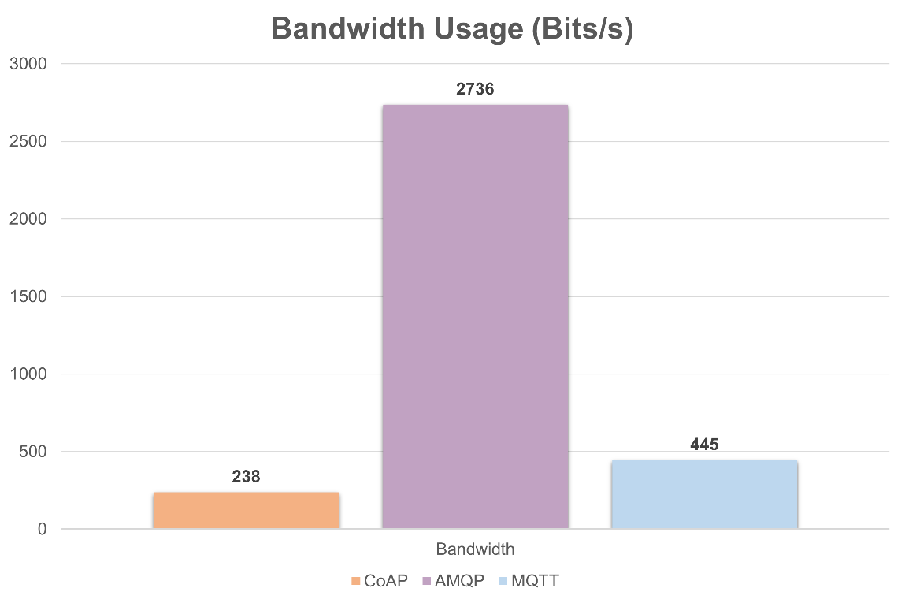

Figure : Bandwidth Usage Graph

1. Latency

AMQP has the lowest latency at 0.3898s, followed by MQTT at 1.4272s and CoAP at 2.1398s. More bandwidths can reduce latency because there is a larger pipeline for more data to travel through, lowering the likelihood of data packets being delayed. Therefore, CoAP with the lowest bandwidth has the highest latency and AMQP with the highest bandwidth has the lowest latency value. Figure 54 depicts the latency results for the three protocols.

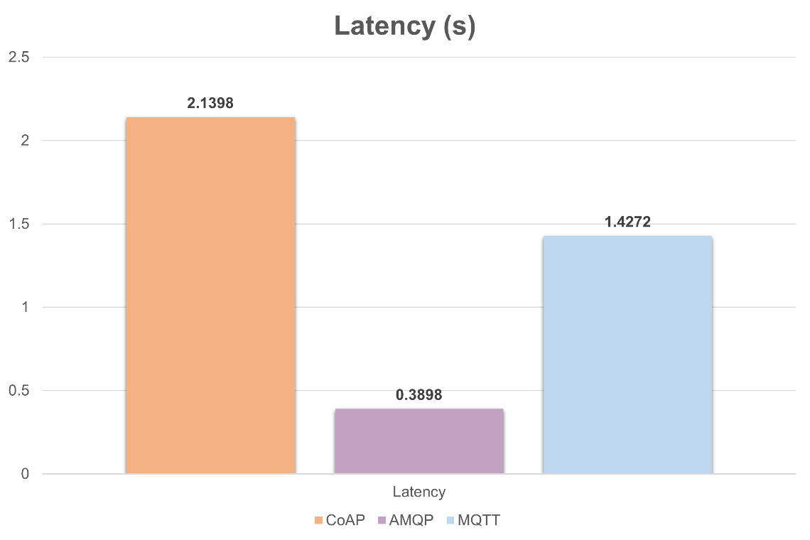

Figure : Latency Graph

1. Throughput

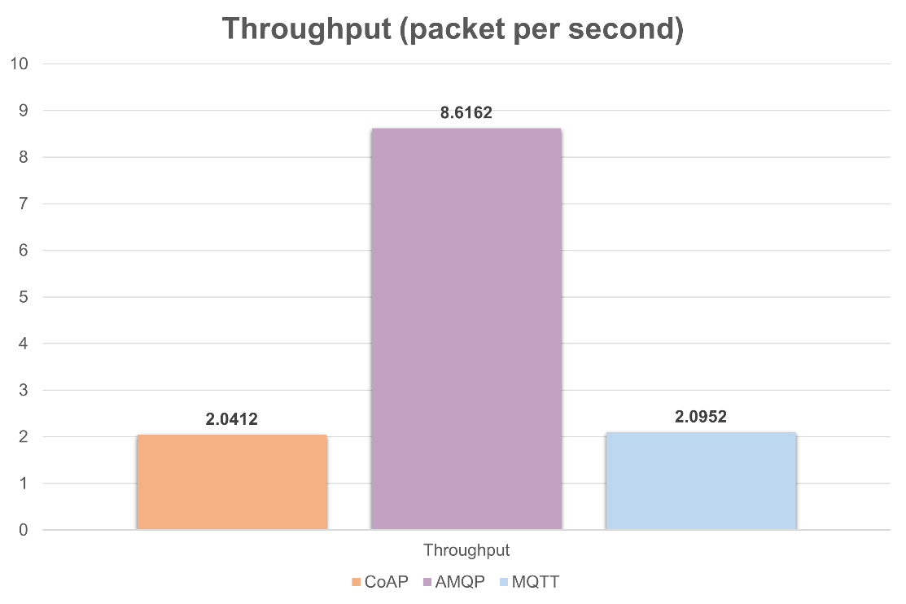

Figure : Throughput Graph

Figure 55 above presents the results for throughput and AMQP protocol has the largest value, 8.6162 packet per second. On the other hand, CoAP protocol has the smallest value at 2.0412 packets per second. The significant difference between MQTT and AMQP as well as between AMQP and CoAP is due to the protocols' message overhead. As previously stated, AMQP requires at least three packages to publish one message, and each message must be acknowledged on the transport layer by TCP, which influences AMQP performance. MQTT outperforms CoAP slightly, achieving 2.0952 packets per second. Moraes et al. (2019) stated in their paper that throughput and message size are related in the sense that a larger message increases the amount of data transmitted. The average packet size for the CoAP protocol is 64 Bytes (Figure 56), while the average packet size for the MQTT protocol is slightly higher at 79 Bytes (Figure 57). This explains why MQTT throughput is slightly higher than CoAP.

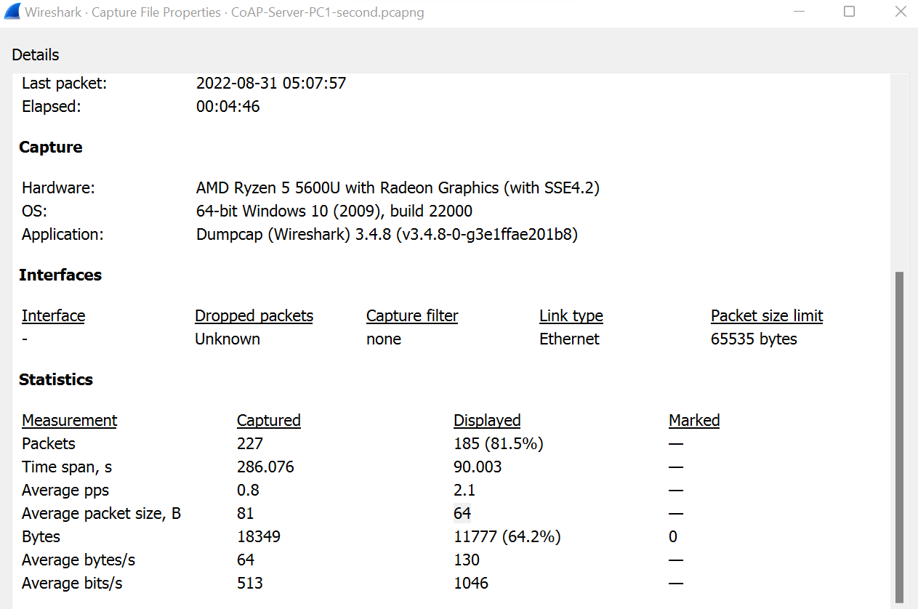

Figure : Average Packet Size (CoAP) from Wireshark

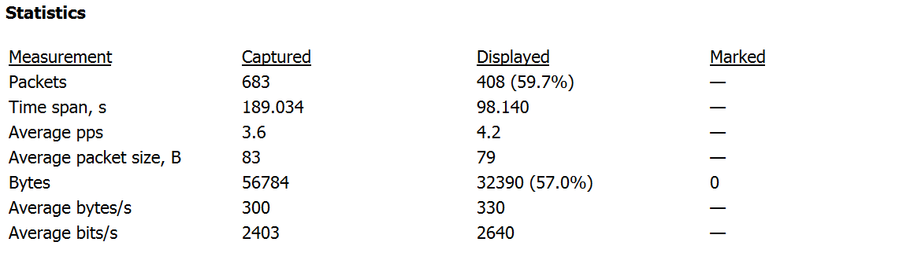

Figure : Average Packet Size (MQTT) from Wireshark

From the experiments, it can be concluded that CoAP obtained the best results. CoAP has the lowest bandwidth usage out of all protocols and lowest throughput due to smaller packet size compared to other protocols. CoAP is capable of sending and receiving 100 messages using less data. From this, it can be concluded that the CoAP is best suited to be used in low bandwidth IoT environment due to its low overhead and it utilizes less network resources than other protocols. In terms of latency and throughput, AMQP outperforms MQTT and CoAP, but it consumes the most bandwidth. As a result, AMQP is thought to be better suited for use in critical systems such as finance, defence, or enterprise-level projects. Based on the results, we can conclude that CoAP and MQTT have minor differences in all of the metrics measured, making them a good alternative to one another. We can deduce that both CoAP and MQTT were appropriate in scenarios requiring a low-bandwidth, high-latency environment.

## Conclusion

This chapter evaluates the performance of IoT protocols such as CoAP, AMQP, and MQTT. The results of each metric are graphically displayed. The explanation of the varying results for each protocol is also provided. This chapter is critical because it concludes the project's main outcome, which is to evaluate the performance of three IoT protocols in terms of bandwidth usage, latency, and throughput.

# PROJECT CONCLUSION

## Introduction

This chapter focuses on summarising all of the project's outcomes and results. This last phase is necessary for ensuring that the goals are met and discussed effectively. The project contribution and limitation are addressed in this chapter. There is also some suggestion on future works regarding the topic studied. This section is vital to the project's efficiency and progress.

## Project Summarization

This study presents a performance analysis of IoT communication protocols, namely CoAP, MQTT & AMQP based on the metrics measured. Bandwidth usage, latency and throughput are the adopted metrics and experiments indicate CoAP protocol provides the best results. Three experiments are conducted in a LAN environment where two workstations and one server are connected via Ethernet switch. The experiments involved message transmission from clients to server.

This project has achieved all the project objectives listed in Chapter 1. The first objective of this project is to assess capabilities of IoT protocols and compare their performance in terms of its bandwidth usage, latency and throughput. This objective is achieved by successfully conducted the experiments planned for all protocols and get all the data needed for the analysis. The second objective is to make recommendations on the protocols based on its the performance evaluation. This objective is achieved by analysed and gave reasons to the varying results from the experiments. It is also achieved as we select CoAP as the best protocol based on the performance analysis.

Strength and weakness of this project are listed in the table below,

Table ‑: Project's Strength and Weakness

|  |  |
| --- | --- |
| **Strength** | **Weakness** |
| * Clients and Server are in the same LAN thus having a reliable low-latency link * Low cost because experiments are conducted using open-source software | * Only few nodes are used to generate traffic |

## Project Contribution

The project contribution is to provide a performance analysis of three specific protocols: CoAP, MQTT & AMQP in terms of bandwidth usage, latency, and throughput. Besides, the project also introduces experimental method to evaluate the performance of IoT protocols. The method includes the usage of GNS3 and virtual machines in a LAN environment.

## Project Limitation

The project's limitation is that the experiments were carried out in a LAN environment, which did not provide a realistic IoT network environment. Another limitation is that the main comparison is limited to the CoAP, MQTT, and AMQP protocols. These are just three of the many protocols used in IoT applications, including OPC Unified Architecture (OPC UA) and Data Distribution Service (DDS), Websocket, etc. Moreover, the experiments used the protocols' default settings and only changed the QoS settings of MQTT to allow a sensor message to reach the server at least once (QoS-1). Another limitation is the metrics measured, as this project assessed three metrics that is bandwidth usage, latency, and throughput.

## Future Works

In the future, the researcher may enhance this project by implementing more nodes or clients in a realistic IoT network environment – server and clients are not in the same LAN. That way, more data can be recorded, and result of analysis could differ. This project only used the basic settings of protocols however researcher may compare the protocols with various QoS or security settings. Other metrics such as power consumption, packet loss rate or jitter can also be used to analyse the performance of protocols in the future.

## Conclusion

To summarize, the Performance Analysis of IoT Protocols (CoAP, MQTT & AMQP) is completed, and all three objectives of this project have been met. Throughout this project, I learned about the three IoT protocols in depth, analysed the difference in performance between those protocols and reached a conclusion in which protocols is the best based on its performance evaluation. Hopefully, this project can help others in finding out the best protocol to be used suited to their intended IoT project’s requirement.

# references

Al Enany, M.O., Harb, H.M. and Attiya, G. (2021). A Comparative analysis of MQTT and IoT application protocols. 2021 International Conference on Electronic Engineering (ICEEM). doi:10.1109/iceem52022.2021.9480384.

Albayrak, M. and Albayrak, A. (2019). Experimental Design for Performance Tests of IoT (Internet of Things) Layers Protocols. Advanced Science, Engineering and Medicine, 11(7), pp.652–658. doi:10.1166/asem.2019.2397.

Aseem (2020). IoT Security - Part 11 (Introduction To CoAP Protocol And Security). [online] Payatu. Available at: <https://payatu.com/blog/aseem/iot-security---part-11-introduction-to-coap-protocol-and-security>. [Accessed 25 April. 2022].

Bansal, S. and Kumar, D. (2019). IoT Application Layer Protocols: Performance Analysis and Significance in Smart City.

Chen, X. (2014). *Constrained Application Protocol for Internet of Things*. URL: https://www. cse. wustl. edu/~ jain/cse574-14/ftp/coap.

Chen, Y. and Kunz, T. (2016). Performance evaluation of IoT protocols under a constrained wireless access network. 2016 International Conference on Selected Topics in Mobile & Wireless Networking (MoWNeT). doi:10.1109/mownet.2016.7496622.

Çorak, B.H., Okay, F.Y., Güzel, M., Murt, Ş. and Ozdemir, S. (2018). Comparative Analysis of IoT Communication Protocols. [online] IEEE Xplore. doi:10.1109/ISNCC.2018.8530963.

Elhadi, S., Marzak, A., Sael, N. and Merzouk, S. (2018). Comparative Study of IoT Protocols. SSRN Electronic Journal. doi:10.2139/ssrn.3186315.

Glaroudis, D., Iossifides, A. and Chatzimisios, P. (2019). Survey, Comparison and Research Challenges of IoT Application Protocols for Smart Farming. Computer Networks, 168, p.107037. doi:10.1016/j.comnet.2019.107037.

Guamán, Y., Ninahualpa, G., Salazar, G. and Guarda, T. (2020). Comparative Performance Analysis between MQTT and CoAP Protocols for IoT with Raspberry PI 3 in IEEE 802.11 Environments. [online] IEEE Xplore. doi:10.23919/CISTI49556.2020.9140905.

Khan, F., Azim, N., Tahir, M., Roohullah, S. and Ullah, F. (2016). USING COAP PROTOCOL FOR RESOURCE OBSERVATION IN IOT Internet of Things meets Bigdata and Cloud Computing View project USING COAP PROTOCOL FOR RESOURCE OBSERVATION IN IOT. International Journal of Emerging Technology in Computer Science & Electronics (IJETCSE), 21, pp.976–1353.

Laaroussi, Z. and Novo, O. (2021). A Performance Analysis of the Security Communication in CoAP and MQTT. 2021 IEEE 18th Annual Consumer Communications & Networking Conference (CCNC). doi:10.1109/ccnc49032.2021.9369565.

Mahesh, S. and Vamsi, K. (2017). PERFORMANCE ANALYSIS OF DATA PROTOCOLS OF INTERNET OF THINGS: A QUALITATIVE REVIEW.

Martí, Garcia-Rubio and Campo (2019). Performance Evaluation of CoAP and MQTT_SN in an IoT Environment. Proceedings, 31(1), p.49. doi:10.3390/proceedings2019031049.

Mijovic, S., Shehu, E. and Buratti, C. (2016). Comparing application layer protocols for the Internet of Things via experimentation. [online] IEEE Xplore. doi:10.1109/RTSI.2016.7740559.

Moraes, T., Nogueira, B., Lira, V. and Tavares, E. (2019). Performance Comparison of IoT Communication Protocols. [online] IEEE Xplore. doi:10.1109/SMC.2019.8914552.

Nadir, Y., Mutlu, T., Üstündağ, A. and Prof (2021). Comparison of IoT Protocols Performance. International Journal of Innovative Science and Research Technology, 6(5).

Naik, N. (2017). Choice of effective messaging protocols for IoT systems: MQTT, CoAP, AMQP and HTTP. [online] IEEE Xplore. doi:10.1109/SysEng.2017.8088251.

Nugroho, H.P., Irfan, M. and Faruq, A. (2019). Software Defined Networks: a Comparative Study and Quality of Services Evaluation. *Scientific Journal of Informatics*, 6(2), pp.181–192. doi:10.15294/sji.v6i2.20585.

Omomule, T.G., Olarinde, D.O., Ugwu, C.C. and Falana, T.A. (2019). *QoS Performance Metrics for Analyzing Wireless Network Usability*. [online] Available at: https://irejournals.com/formatedpaper/1701830.pdf.

Pohl, M., Kubela, J., Bosse, S. and Turowski, K. (2018). Performance Evaluation of Application Layer Protocols for the Internet-of-Things. 2018 Sixth International Conference on Enterprise Systems (ES). doi:10.1109/es.2018.00035.

RF Wireless World (n.d). Advantages of CoAP protocol | disadvantages of CoAP protocol. [online] www.rfwireless-world.com. Available at: https://www.rfwireless-world.com/Terminology/Advantages-and-Disadvantages-of-CoAP.html [Accessed 25 April. 2022].

Sidna, J., Amine, B., Abdallah, N. and El Alami, H. (2020). Analysis and evaluation of communication Protocols for IoT Applications. Proceedings of the 13th International Conference on Intelligent Systems: Theories and Applications. doi:10.1145/3419604.3419754.

Silva, D., Carvalho, L.I., Soares, J. and Sofia, R.C. (2021). A Performance Analysis of Internet of Things Networking Protocols: Evaluating MQTT, CoAP, OPC UA. Applied Sciences, 11(11), p.4879. doi:10.3390/app11114879.

Sueda, Y., Sato, M. and Hasuike, K. (2019). Evaluation of Message Protocols for IoT. 2019 IEEE International Conference on Big Data, Cloud Computing, Data Science & Engineering (BCD). doi:10.1109/bcd.2019.8884975.

Tandale, U., Momin, B. and Seetharam, D.P. (2017). An empirical study of application layer protocols for IoT. 2017 International Conference on Energy, Communication, Data Analytics and Soft Computing (ICECDS). doi:10.1109/icecds.2017.8389890.

Uy, N.Q. and Nam, V.H. (2019). A comparison of AMQP and MQTT protocols for Internet of Things. 2019 6th NAFOSTED Conference on Information and Computer Science (NICS). doi:10.1109/nics48868.2019.9023812.

Wireshark Foundation (2016). Wireshark. [online] Wireshark.org. Available at: <https://www.wireshark.org/>.

www.oreilly.com. (n.d.). *1. Primer on Latency and Bandwidth - High Performance Browser Networking [Book]*. [online] Available at: https://www.oreilly.com/library/view/high-performance-browser/9781449344757/ch01.html#:~:text=Latency%20is%20the%20time%20it [Accessed 1 Aug. 2022].